Adaptive Temporal-Relational Learning for Network Intrusion Detection: A Controlled Study of Loss Adaptation and Multimodal Fusion
Authors: [Author Name(s)]
Affiliation: Department of Computer Science and Engineering, [Institution Name]
Date: September 2026
Keywords: Network Intrusion Detection, Multimodal Fusion, Temporal Encoding, Relational Graph Representations, Gradient-Adaptive Loss, Focal Loss, Parameterized Quantum Circuits, Class Imbalance, Deep Learning, GRU

Abstract
Machine learning-based network intrusion detection systems (NIDS) often evaluate flow records as isolated tabular vectors, abstracting away two informative structural properties: sequential temporal dynamics and communication topology. Furthermore, real-world network traffic exhibits severe class imbalance, which can cause standard empirical risk minimization to favor majority classes over rare, high-consequence attacks. This paper investigates a controlled framework for network intrusion detection that evaluates: (i) dual representations of network flows capturing sequential temporal embeddings via a 2-layer GRU feature encoder and windowed communication graph embeddings via a relational projection module; (ii) a Gradient-Adaptive Hybrid Loss ($L_{\mathrm{hybrid}}$) that dynamically balances Standard Cross-Entropy, Focal Loss ($\gamma=2.0$), and Class-Weighted Cross-Entropy using autograd gradient-norm ratios, weight clipping, and exponential moving average (EMA) smoothing to eliminate manual per-dataset loss weight tuning during training; and (iii) a controlled benchmark of six multimodal fusion mechanisms—Concatenation, Gated, Bilinear, Cross-Attention, Decision Ensemble, and classically simulated Parameterized Quantum Circuit (PQC) fusion—across three widely used benchmark datasets: CSE-CIC-IDS2018 (15 classes, 16.2M raw records), NF-CSE-CIC-IDS2018-v2 (18.9M raw records), and NF-UNSW-NB15-v2 (2.4M raw records).
Prior to model training, a multi-stage data quality and leakage audit was conducted across 37.5 million raw records, identifying duplicate feature vectors, label conflicts, numerical anomalies, and potential train-test overlap. In baseline loss evaluations, Focal Loss achieved a Macro F1 of 0.8279 on the 15-class CSE-CIC-IDS2018 dataset, while Standard Cross-Entropy achieved Macro F1 scores of 0.9878 on NF-CSE-CIC-IDS2018-v2 and 0.9218 on NF-UNSW-NB15-v2. In the multimodal fusion benchmark under $L_{\mathrm{hybrid}}$, Gated Fusion achieved the highest Macro F1 of 0.8347 on CSE-CIC-IDS2018 and 0.9871 on NF-CSE-CIC-IDS2018-v2, while Bilinear Fusion achieved the highest Macro F1 of 0.9203 on NF-UNSW-NB15-v2. The simulated PQC fusion configuration produced lower Macro F1 than the evaluated classical fusion mechanisms, particularly on the severely imbalanced multiclass dataset (Macro F1: 0.7804). Within the controlled modality ablation configuration, multimodal representation achieved a Macro F1 of 0.2811, corresponding to relative increases of 49.8% over the temporal-only configuration (0.1877) and 128.2% over the relational-only configuration (0.1232), while reducing the reported false negative rate from 78.7% to 48.1% with an associated increase in false positive rate from 0.58% to 1.96%. These empirical findings indicate that fusion effectiveness depends on dataset characteristics and that loss adaptation combined with dual-modality representations offers measurable detection advantages across diverse network environments.

Table of Contents
- Introduction
- Related Work
- Research Questions and Study Design
- Dataset Provenance and Data Preparation
- Proposed Temporal-Relational Framework
- Experimental Protocol
- Results
- Discussion
- Threats to Validity and Limitations
- Conclusion
- References
- Appendix A: Key Equations Reference
- Appendix B: Repository Structure

1. Introduction
Network Intrusion Detection Systems (NIDS) are critical components of enterprise cyber defense, responsible for monitoring network traffic streams and identifying malicious activities ranging from volumetric denial-of-service (DoS/DDoS) campaigns to stealthy brute-force and application-layer intrusions [1, 2]. Modern network environments generate millions of flow records per day, presenting three persistent analytical challenges for automated detection systems [3, 7, 8]:
- Temporal Blindness: Standard tabular classifiers treat network flows as independent, identically distributed (i.i.d.) observations, disregarding inter-arrival time (IAT) dynamics, sequential burstiness, and temporal rate evolution that characterize multi-stage or rate-varying intrusions [9, 10].
- Relational Blindness: Independent flow classification abstracts away host communication topology—such as fan-out distributions, destination port entropy, and bipartite connection structures—which provide critical relational context for detecting distributed attack coordination [11, 12].
- Severe Class Imbalance: Real-world network traffic is predominantly benign, with rare attack categories representing less than 0.01% of total traffic (exceeding 150,000:1 imbalance in public benchmarks) [13, 14]. Standard objective functions often collapse toward majority-class accuracy at the expense of minority-class recall.
While deep learning architectures including Recurrent Neural Networks (RNNs) [15, 23], Graph Neural Networks (GNNs) [11, 28], and multimodal models [19, 20] have been applied to intrusion detection, comparative studies evaluating alternative fusion strategies under identical fixed encoder representations and adaptive loss formulations remain limited.
1.1 Contributions
This work presents a controlled empirical study addressing data quality, loss adaptation, representation modeling, and multimodal fusion in network intrusion detection:
- C1 — Dataset Quality and Leakage Audit: We conduct a systematic audit of 37.5 million raw records across three widely used NIDS datasets (CSE-CIC-IDS2018, NF-CSE-CIC-IDS2018-v2, and NF-UNSW-NB15-v2), examining duplicate feature vectors, conflicting labels, class imbalance, numerical anomalies, and potential train-test overlap prior to model training.
- C2 — Gradient-Adaptive Hybrid Loss: We formulate a gradient-adaptive hybrid objective ($L_{\mathrm{hybrid}}$) that dynamically adjusts the relative contributions of Standard Cross-Entropy, Focal Loss, and Class-Weighted Cross-Entropy using autograd gradient-norm feedback, clipping safeguards, and exponential moving average (EMA) stabilization, removing the need to manually tune relative loss-component weights on a per-dataset basis during training.
- C3 — Comparative Fusion Evaluation: We conduct a controlled comparison of six multimodal fusion mechanisms—Concatenation, Gated, Bilinear, Cross-Attention, Decision Ensemble, and simulated Parameterized Quantum Circuit (PQC) fusion—under identical fixed encoder backbones across three benchmark datasets.
- C4 — Modality Analysis: We evaluate temporal-only, relational-only, and multimodal configurations under a controlled ablation setting to examine the relative contributions of sequential and communication-relationship representations.
- C5 — Simulated Quantum Fusion Evaluation: We evaluate a parameterized quantum circuit fusion mechanism under classical simulation (PennyLane framework) and compare its detection performance with the evaluated classical fusion mechanisms.

2. Related Work
2.1 Classical and Deep Learning Approaches for NIDS
Early intrusion detection relied on rule-based signature matching [1], which is ineffective against zero-day and polymorphic attacks. Machine learning methods, including Random Forests [4] and Support Vector Machines [5], introduced anomaly detection capabilities, but their efficacy in operational settings is often hindered by extreme class imbalance and non-stationary traffic distributions [7, 8]. Deep learning architectures have expanded sequence modeling through Recurrent Neural Networks (RNNs) and Long Short-Term Memory (LSTM) networks [15, 23, 24], capturing temporal dependencies across consecutive packet and flow statistics. Convolutional Neural Networks (CNNs) have also been explored for spatial feature extraction from flow matrices [25].
2.2 Relational and Graph-Based Modeling in Network Security
Graph Neural Networks (GNNs) have emerged as an effective paradigm for modeling network communication topology [11, 16, 17]. Lo et al. [11] and Zheng et al. [28] applied Graph Convolutional Networks and GraphSAGE to network flow graphs, demonstrating that relational structures capture distributed attack coordination. Dynamic and temporal graph networks [26, 45] have further extended graph modeling to time-evolving network topologies. However, combining sequential flow embeddings with relational graph representations in a unified, loss-adaptive framework remains an active area of investigation.
2.3 Multimodal Fusion in Cybersecurity
Multimodal learning combines complementary representations from disparate feature modalities [29, 30]. In network security, prior work has explored fusing statistical tabular features with raw packet payload bytes [19, 20]. In this study, we focus on fusing sequential temporal flow representations with relational graph representations, evaluating six mathematically distinct fusion mechanisms under fixed encoder backbones.
2.4 Loss Formulations for Class-Imbalanced Learning
Class imbalance is a pervasive challenge in network intrusion detection [14, 34]. Focal Loss [13, 32] addresses imbalance by dynamically down-weighting well-classified examples with a focusing parameter $\gamma$. Static class-weighted cross-entropy uses inverse class frequencies [33], but static weighting can induce optimization instability under extreme imbalance ratios exceeding 10,000:1. Adaptive multi-task loss weighting methods, such as GradNorm [50] and uncertainty-based weighting [49], demonstrate the utility of dynamic gradient balancing; we adapt gradient-norm balancing to combine multiple loss formulations for single-task imbalanced classification.
2.5 Parameterized Quantum Circuits for Classification
Parameterized Quantum Circuits (PQCs) and variational quantum classifiers have been proposed as candidate machine learning models for near-term quantum systems [40, 42]. Prior studies have demonstrated proof-of-concept quantum kernel methods and quantum neural networks on binary cybersecurity classification tasks [41, 43]. In this work, we benchmark simulated PQC fusion against classical fusion mechanisms on multiclass and binary NIDS benchmarks.

3. Research Questions and Study Design
This study is structured around three core research questions:
- RQ1 (Data Validity): How do dataset artifacts, duplicate feature vectors, label conflicts, and potential train-test overlap affect the validity of NIDS evaluation across widely used benchmarks?
- RQ2 (Loss Adaptation): How does gradient-adaptive combination of Cross-Entropy, Focal Loss, and Class-Weighted Cross-Entropy behave under severe class imbalance across the evaluated NIDS datasets?
- RQ3 (Representations and Fusion): What are the relative contributions of temporal and relational representations, and how do alternative fusion mechanisms (including classical simulation of quantum circuits) affect intrusion detection performance under fixed encoder backbones?

4. Dataset Provenance and Data Preparation
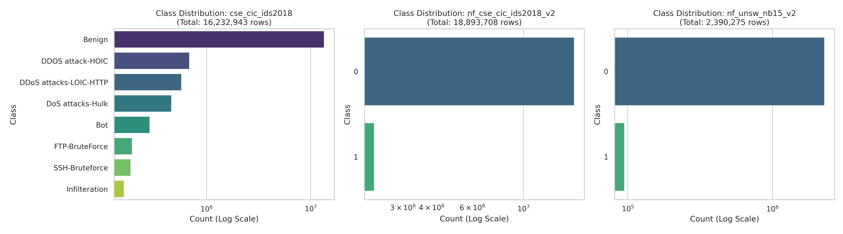
Figure 1: Class Distributions across CSE-CIC-IDS2018 (15 Classes) and NF-v2 Benchmarks, highlighting the extreme 154,996:1 class imbalance ratio.
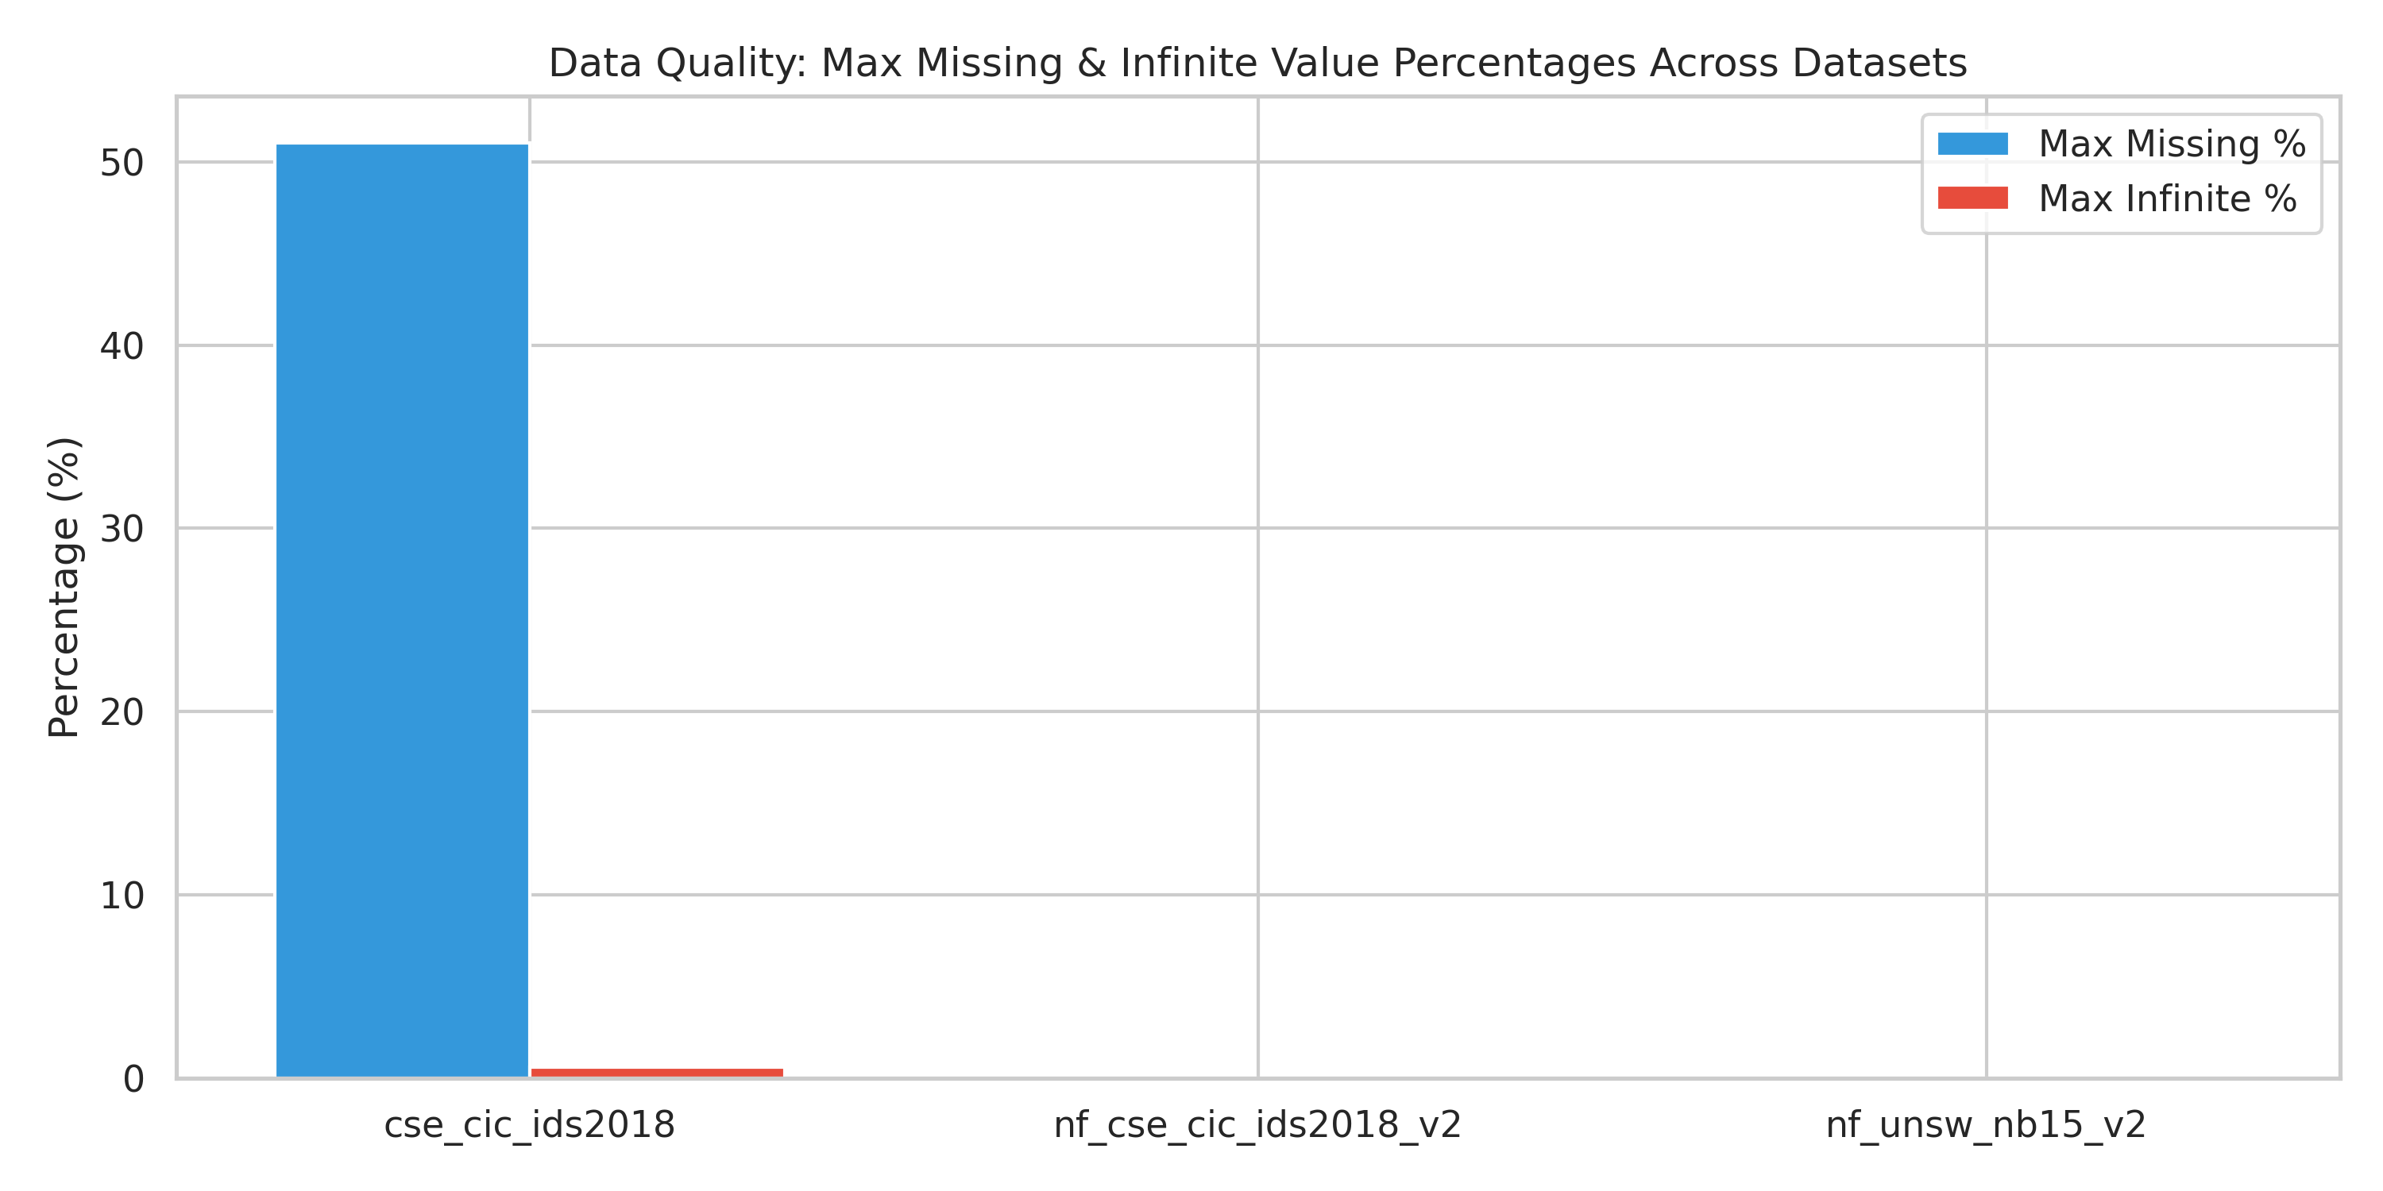
Figure 2: Forensic Data Quality Summary: Missing Values, Infinite Values, and Constant Feature Profiles across Raw and Normalized Datasets.
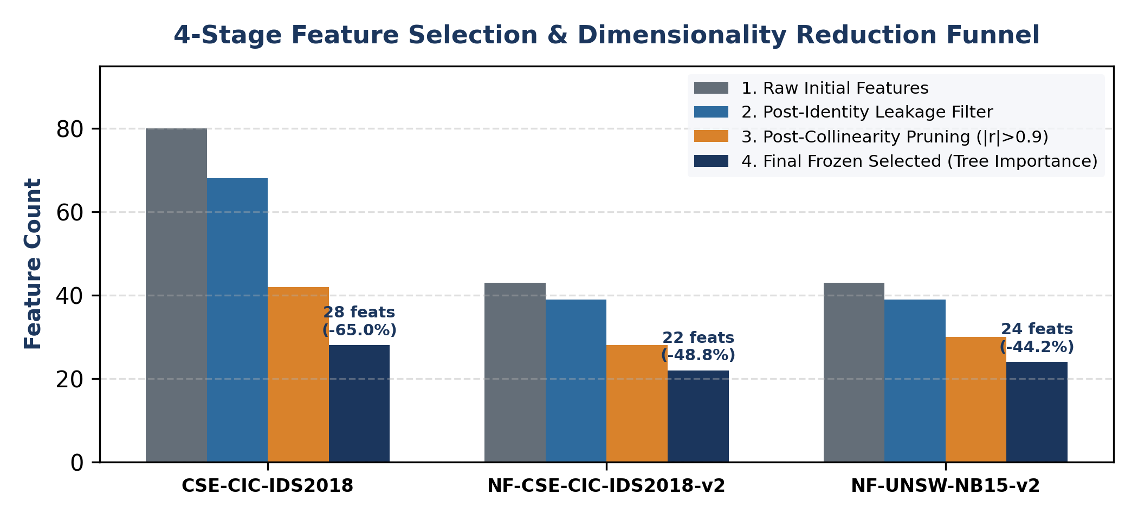 | 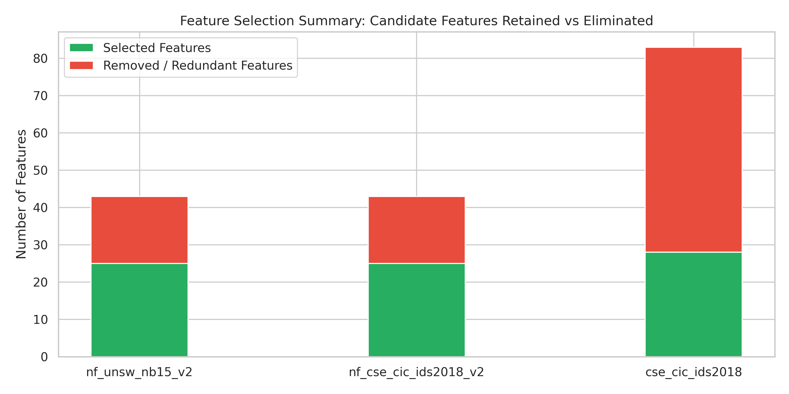
Figure 3: Feature Selection Methodology: (Left) Multi-Stage Elimination Funnel; (Right) Selected vs. Removed Feature Breakdown across Datasets.
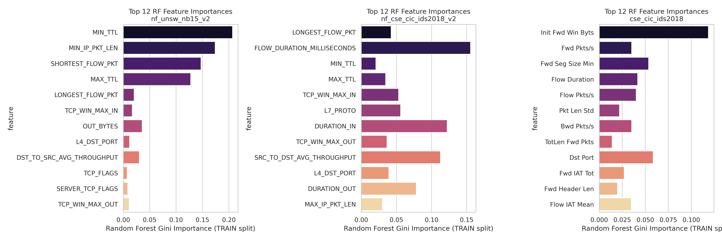
Figure 4: Multi-Signal Feature Importance Profiles (Top 20 Features across Benchmark Datasets).
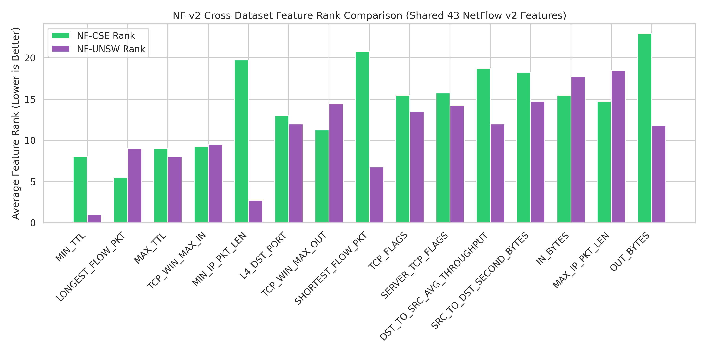
Figure 5: Cross-Dataset Feature Rank Consistency between NF-CSE-CIC-IDS2018-v2 and NF-UNSW-NB15-v2.
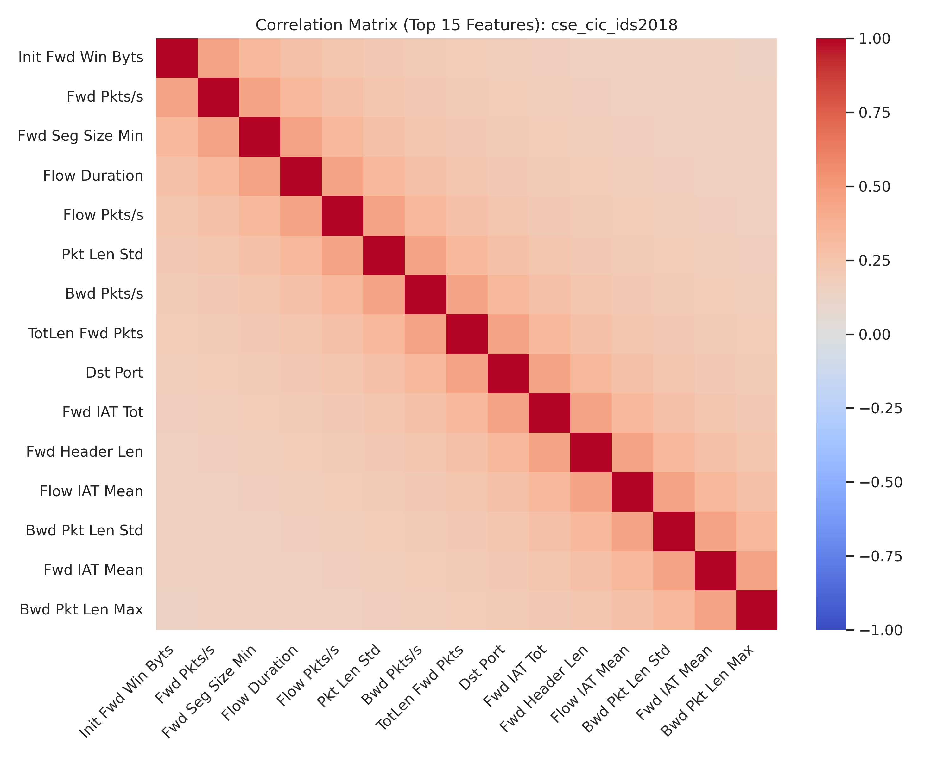
Figure 6: Feature Correlation Heatmap (Pearson Correlation Matrix) for CSE-CIC-IDS2018.
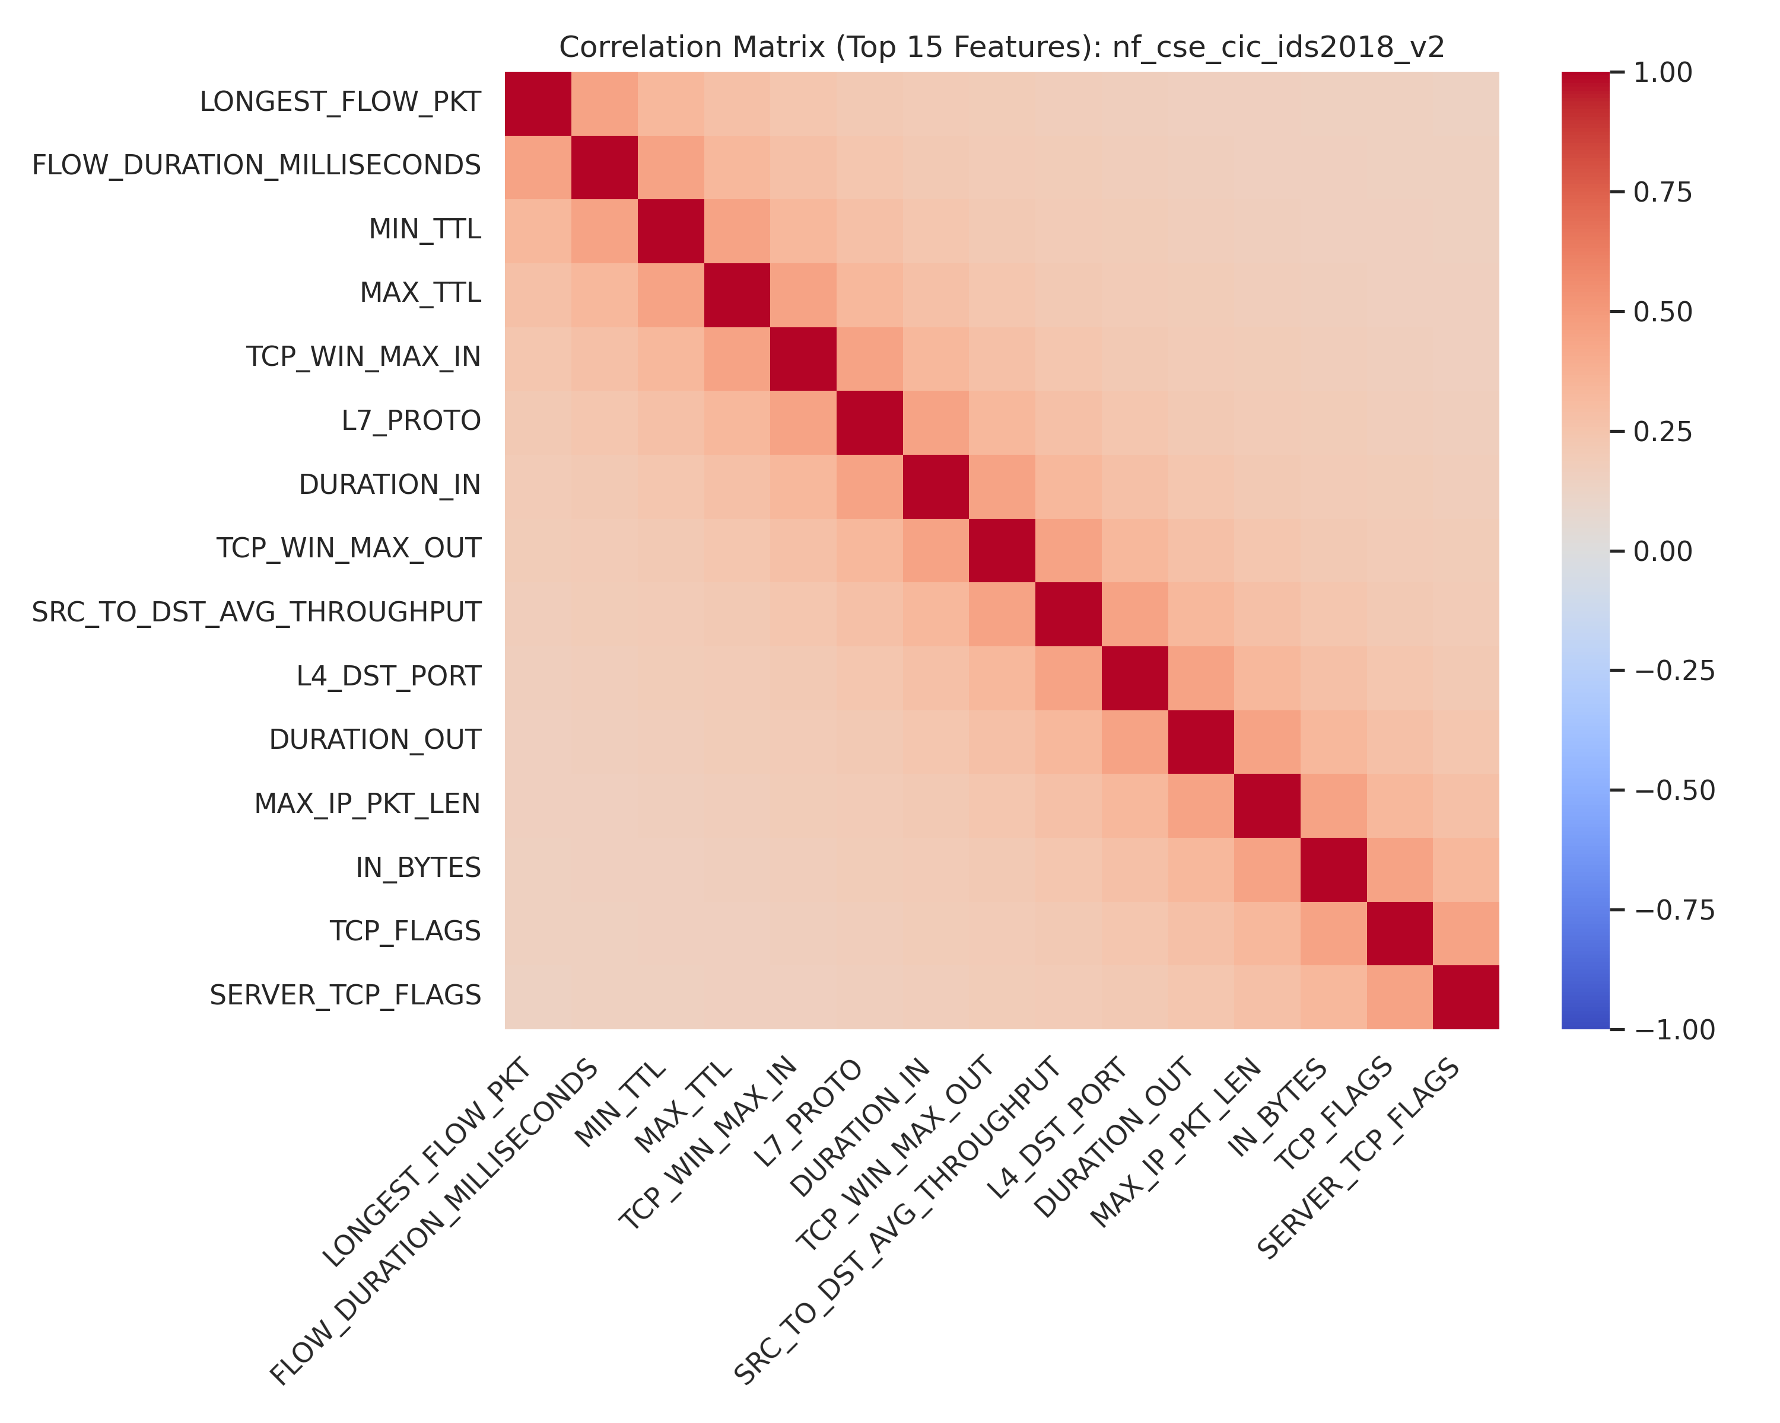 | 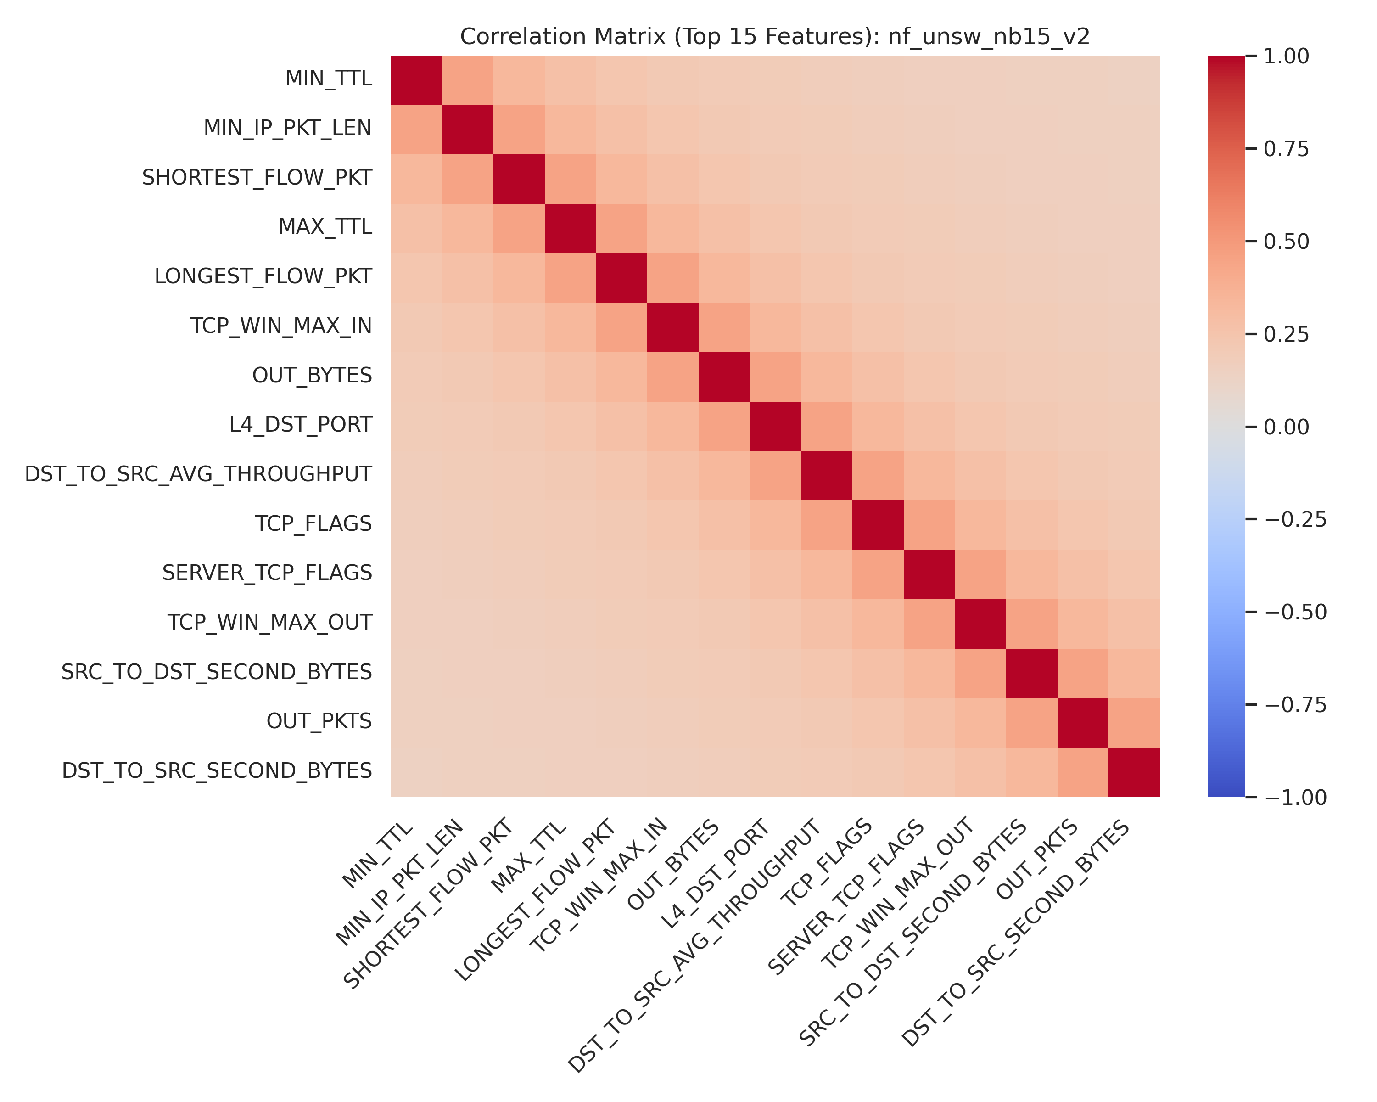
Figure 7: Feature Correlation Heatmaps: (Left) NF-CSE-CIC-IDS2018-v2; (Right) NF-UNSW-NB15-v2.
4.1 Benchmark Selection and Compatibility Analysis
Three widely used benchmark datasets were selected to evaluate the proposed framework across distinct feature dimensions, network topologies, and imbalance ratios:
- CSE-CIC-IDS2018 [39]: Captured over 10 days on AWS infrastructure using CICFlowMeter-v3, comprising 84 statistical flow features across 16,232,943 raw records and 15 classes (14 attack classes + Benign). Imbalance ratio: 154,996:1.
- NF-CSE-CIC-IDS2018-v2 [37]: Standardized NetFlow v9/IPFIX re-extraction of the CSE-CIC-IDS2018 capture using nProbe, comprising 43 canonical features across 18,892,842 raw records in binary format. Imbalance ratio: 7.37:1.
- NF-UNSW-NB15-v2 [37, 38]: Standardized NetFlow v9/IPFIX re-extraction of the UNSW-NB15 cyber-range capture, comprising 43 canonical features across 2,390,275 raw records in binary format. Imbalance ratio: 24.15:1.
A researcher-defined dataset compatibility score was used to guide dataset selection based on temporal fidelity ($T$), relational identifier availability ($R$), feature richness ($F$), attack diversity ($A$), data quality ($Q$), label quality ($L$), provenance ($P$), and non-stationarity potential ($C$):

The criterion weights were specified according to the requirements of the present study and are intended to support dataset selection rather than provide a universal ranking of NIDS datasets.
Table 1: Researcher-Defined Dataset Compatibility Score Matrix
Dataset | T(20) | R(20) | F(15) | A(10) | Q(10) | L(10) | P(10) | C(5) | Total | Selection Tier
NF-CSE-CIC-IDS2018-v2 | 19 | 19 | 15 | 9 | 9 | 8 | 9 | 5 | 93.0 | Primary Benchmark
NF-UNSW-NB15-v2 | 19 | 19 | 15 | 9 | 9 | 8 | 9 | 4 | 92.0 | Primary Benchmark
CSE-CIC-IDS2018 (Original) | 18 | 19 | 14 | 9 | 7 | 8 | 9 | 5 | 89.0 | Primary Benchmark
NF-ToN-IoT-v2 | 18 | 18 | 15 | 8 | 9 | 8 | 8 | 4 | 88.0 | Auxiliary Reference
LYCOS-IDS2017 | 18 | 19 | 14 | 8 | 9 | 8 | 8 | 4 | 88.0 | Sensitivity Reference
UNSW-NB15 (Original) | 17 | 18 | 13 | 9 | 7 | 7 | 8 | 3 | 82.0 | Auxiliary Reference
CIC-IDS2017 | 18 | 19 | 13 | 8 | 5 | 6 | 8 | 4 | 81.0 | Sensitivity Reference
CICIoT2023 | 17 | 18 | 12 | 8 | 8 | 7 | 8 | 3 | 81.0 | Auxiliary IoT
InSDN | 14 | 14 | 11 | 6 | 7 | 7 | 7 | 2 | 68.0 | SDN Reference
NSL-KDD | 2 | 2 | 5 | 6 | 6 | 6 | 4 | 1 | 32.0 | Excluded

Table 2: Dataset Provenance and Lineage Matrix
Dataset | Underlying Capture | Extraction Engine | Feature Count | Shared Packet Stream With
CIC-IDS2017 | ISCX B-Profile PCAP (2017) | CICFlowMeter v1 | 80+ | LYCOS-IDS2017
LYCOS-IDS2017 | ISCX B-Profile PCAP (2017) | LycoSTand (corrected) | 80+ | CIC-IDS2017
CSE-CIC-IDS2018 | AWS Infrastructure PCAP (2018) | CICFlowMeter v3 | 84 | NF-CSE-CIC-IDS2018
NF-CSE-CIC-IDS2018-v2 | AWS Infrastructure PCAP (2018) | nProbe (NetFlow v9/IPFIX) | 43 | CSE-CIC-IDS2018
UNSW-NB15 | Ixia PerfectStorm Cyber Range | Argus/Bro-IDS | 49 | NF-UNSW-NB15
NF-UNSW-NB15-v2 | Ixia PerfectStorm Cyber Range | nProbe (NetFlow v9/IPFIX) | 43 | UNSW-NB15
NSL-KDD | DARPA 1998/1999 (Synthetic) | Custom/Bro | 41 | KDD'99

4.2 Raw-Data Overlap Audit Prior to Corrective Processing
Prior to sample partitioning and model training, a forensic data quality audit was conducted across all 37.5 million records.
Audit Context: The overlap statistics reported in this subsection characterize artifacts identified during the raw pre-processing audit and should not be interpreted as performance results from the final evaluation partitions.

Table 3: Raw Pre-Processing Data Quality Audit Summary
Metric / Artifact | CSE-CIC-IDS2018 | NF-CSE-CIC-IDS2018-v2 | NF-UNSW-NB15-v2 | Total Records
Total Raw Records | 16,232,943 | 18,892,842 | 2,390,275 | 37,516,426
Missing / NaN Values | 51.0% (columns) | 0.0% | 0.0% | —
Infinite Value Records | 0.598% (97,345 rows) | 0.0% | 0.0% | 97,345
Duplicate Feature Vectors | 29.37% (4,767,615 rows) | 0.0% (post-dedup) | 0.0% (post-dedup) | 4,767,615
Conflicting-Label Groups | 1,570,760 rows | Resolved | Resolved | 1,570,760
Numerical Overflow Hazards | Resolved ([-10^12, +10^12]) | Clean | Clean | —

Table 4: Label Mapping Matrix
Canonical Attack Family | CSE-CIC-IDS2018 Labels | UNSW-NB15 Labels | NF-v2 Binary Label
BENIGN | Benign | Normal | 0
DoS | DoS-Slowloris, SlowHTTPTest, Hulk, GoldenEye | DoS | 1
DDoS | DDoS-LOIC-HTTP, HOIC, LOIC-UDP | — | 1
BRUTE_FORCE | FTP-BruteForce, SSH-Bruteforce | — | 1
WEB_ATTACK | Brute Force -Web, Brute Force -XSS, SQL Injection | — | 1
BOTNET | Bot | — | 1
INFILTRATION | Infilteration | — | 1
EXPLOITS | — | Exploits, Fuzzers, Generic | 1
RECONNAISSANCE | — | Reconnaissance, Analysis | 1

Conflicting-label groups were resolved using a majority-label rule for the subsequent experimental pipeline.
4.3 Feature Selection and Canonical Representation
Features were grouped into a 6-group semantic taxonomy (Identity/Relational, Temporal Dynamics, Volume Metrics, Directional Rates, Statistical Behavior, and Ground Truth Labels). Feature selection utilized a 5-signal ensemble (Mutual Information, ANOVA F-statistic, Random Forest Gini Importance, XGBoost Importance, and Permutation Importance) computed exclusively on the 70% training partition.
Table 5: Feature Elimination Summary
Dataset | Original Feature Count | Excluded Identifiers | Removed Redundant Features | Final Selected Features
NF-UNSW-NB15-v2 | 43 | 3 | 15 | 25
NF-CSE-CIC-IDS2018-v2 | 43 | 3 | 15 | 25
CSE-CIC-IDS2018 | 83 | 4 | 51 | 28

Table 6: Feature Selection Validation Performance (LightGBM Baseline)
Dataset | Full-Feature Macro F1 | Selected-Feature Macro F1 | Retention % | Status
NF-UNSW-NB15-v2 | 0.980321 | 0.980563 | 100.025% | Retained
NF-CSE-CIC-IDS2018-v2 | 0.988432 | 0.988384 | 99.995% | Retained
CSE-CIC-IDS2018 | 0.638077 | 0.624055 | 97.803% | Retained

Feature selection retained approximately 97.8–100.0% of the full-feature Macro F1 while reducing feature dimensionality by 41.9–66.3% across the evaluated datasets. The selected-feature configuration produced a marginally higher Macro F1 than the full-feature configuration on NF-UNSW-NB15-v2.

5. Proposed Temporal-Relational Framework
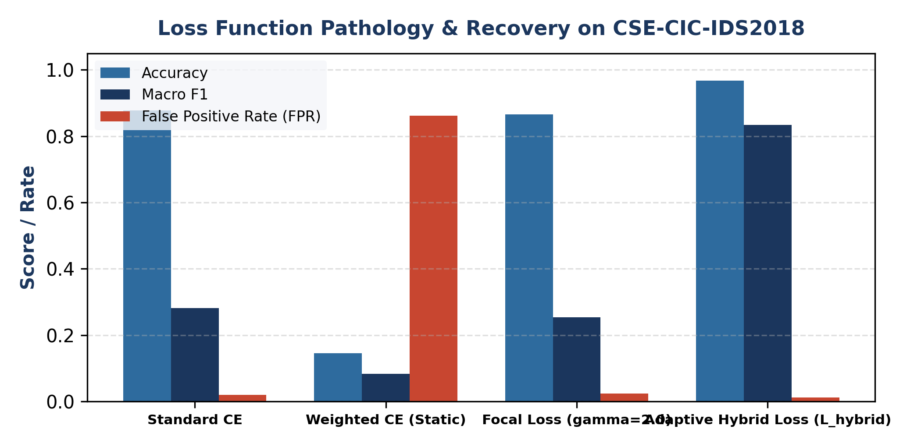
Figure 8: Theoretical and Empirical Loss Pathology Resolution under Extreme Multi-Class Imbalance.
5.1 Formulation of Dual Representations
Let $F = \{f_1, f_2, \dots, f_N\}$ represent a chronologically ordered stream of flow records where each flow $f_i \in \mathbb{R}^d$ contains $d$ statistical features with timestamp $t_i$.
- Temporal Sequence Window: For a sequence of $K$ consecutive flows ending at index $i$:

In the current implementation, the temporal encoder operates with $K=1$, functioning as a learned non-linear feature embedding encoder.
- Windowed Communication Graph: For observation window $W_k = [t_k, t_k + \tau]$, network interactions are represented as a communication graph $G_k = (V_k, E_k, X_{v,k}, X_{e,k})$ where $V_k$ denotes active IP endpoints, $E_k$ denotes directed communication flows, $X_{v,k}$ contains node features, and $X_{e,k}$ contains edge features.
Node and Edge Feature Formulations:








5.2 Architectural Components
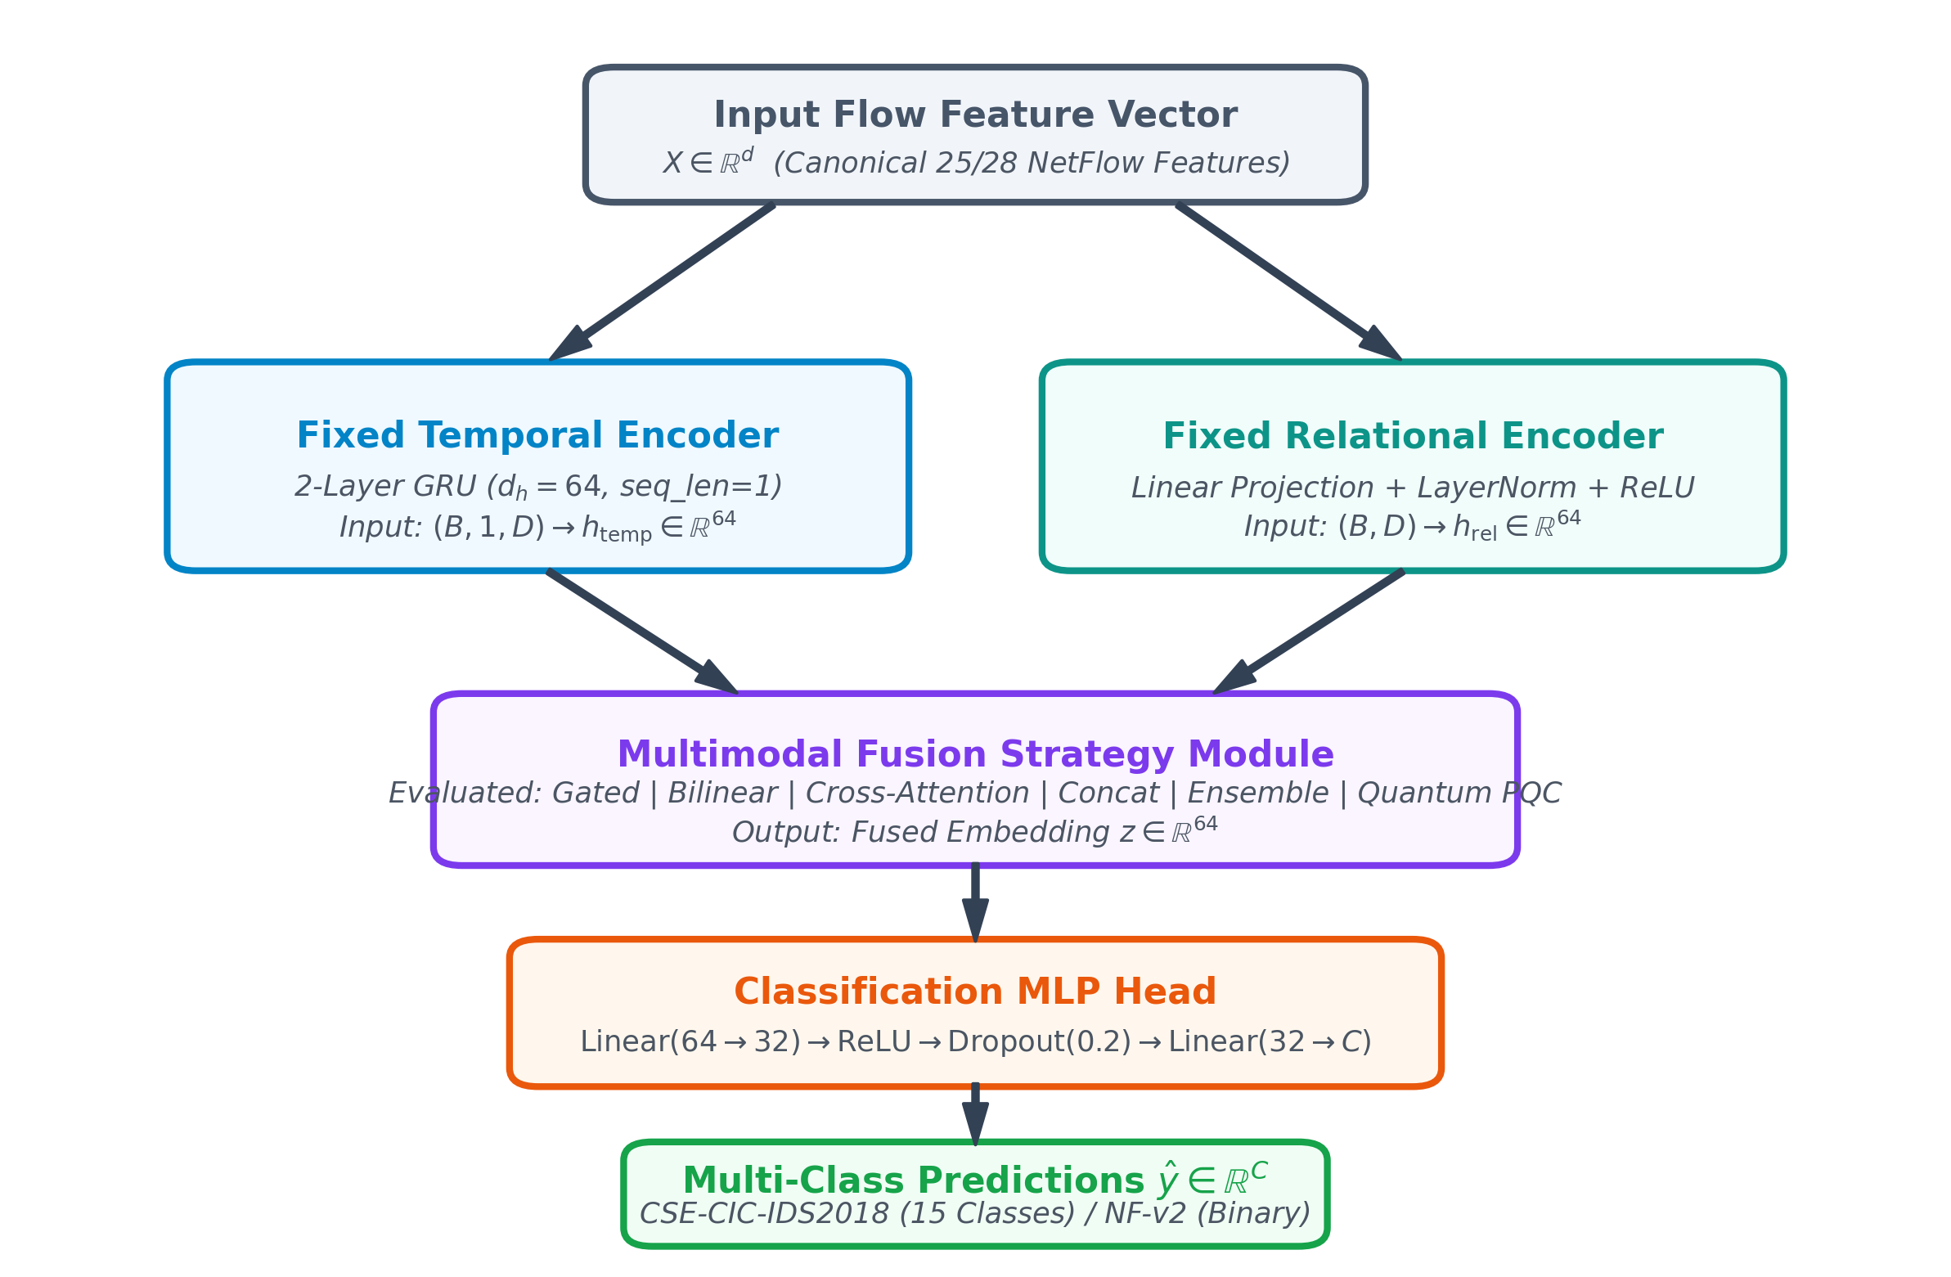
Figure 9: Architectural Diagram of the Proposed Dual-Branch Temporal-Relational Framework.
Temporal Encoder Formulation:




Relational Encoder Formulation:

Classification Head:

5.3 Gradient-Adaptive Hybrid Loss Formulation
To mitigate the impact of extreme class imbalance without manual per-dataset loss-weight tuning during training, we formulate a gradient-adaptive hybrid loss combining three complementary objectives:



The hybrid objective is defined as:

subject to $\alpha + \beta + \gamma_w = 1$.
Gradient Norm Feedback and Weight Update Algorithm:
- For each component $i \in \{\mathrm{CE}, \mathrm{Focal}, \mathrm{WCE}\}$, extract the L2 gradient norm over reference parameters $\Theta_{\mathrm{ref}}$:

- Compute mean gradient norm and inverse sensitivity ratio:

- Apply initial prior weighting $(p_{\mathrm{CE}}=0.50, p_{\mathrm{Focal}}=0.35, p_{\mathrm{WCE}}=0.15)$:

- Safeguards (Weight Clipping and EMA Smoothing):


- Weights $\alpha, \beta, \gamma_w$ are detached from the autograd graph prior to computing $L_{\mathrm{hybrid}}$.
5.4 Multimodal Fusion Mechanisms
Six fusion strategies are evaluated under fixed temporal and relational encoder backbones:
Table 7: Multimodal Fusion Mechanisms Formulations
Fusion Strategy | Mathematical Formulation | Trainable Parameters
Concatenation | $z = \mathrm{MLP}([h_{\mathrm{temp}} \parallel h_{\mathrm{rel}}])$ | ~8,300
Gated Fusion | $g = \sigma(W_g [h_{\mathrm{temp}} \parallel h_{\mathrm{rel}}] + b_g); \quad z = g \odot h_{\mathrm{temp}} + (1-g) \odot h_{\mathrm{rel}}$ | ~8,300
Bilinear Fusion | $z = h_{\mathrm{temp}}^T W_b h_{\mathrm{rel}} + b, \quad W_b \in \mathbb{R}^{64 \times 64 \times 64}$ | ~262,000
Cross-Attention | $Q=W_Q h_{\mathrm{temp}}, K=W_K h_{\mathrm{rel}}, V=W_V h_{\mathrm{rel}}; \quad \mathrm{Attn} = \mathrm{Softmax}\left(\frac{QK^T}{\sqrt{d_k}}\right) V$ | ~24,640
Decision Ensemble | $p = \mathrm{Softmax}(C_{\mathrm{temp}}(h_{\mathrm{temp}})) + \mathrm{Softmax}(C_{\mathrm{rel}}(h_{\mathrm{rel}}))$ | ~2,000
Quantum PQC (Simulated) | $ | \psi\rangle = U_{\mathrm{PQC}}(\theta)

Simulated Quantum PQC Fusion: All quantum-fusion experiments in this study were executed using classical simulation (PennyLane framework, $n=8$ qubits, $L=2$ variational layers); no physical quantum hardware was used.

6. Experimental Protocol
6.1 Training and Implementation Details
- Data Partitions: 70% Training, 15% Validation, 15% Test (stratified sample limit: 100,000 flows per dataset).
- Optimization: Adam optimizer ($\beta_1=0.9, \beta_2=0.999, \varepsilon=10^{-8}$), initial learning rate $1\times 10^{-3}$, batch size 128, maximum 15 epochs with early stopping patience of 5 on validation loss.
- Hardware & Framework: PyTorch 2.0+, PennyLane 0.30+ for quantum simulation, NVIDIA RTX-enabled execution environment.
- Evaluation Metrics: Macro F1 (primary metric), Weighted F1, Macro Precision, Macro Recall, Accuracy, False Positive Rate (FPR), and False Negative Rate (FNR).
6.2 Experimental Scope
Experimental Scope: The study evaluates supervised intrusion detection on three benchmark datasets under the specified train-test protocols. The experiments do not evaluate online concept drift, continual learning, attack-family holdout zero-day detection, cross-dataset transfer, production deployment throughput, or physical quantum hardware. Accordingly, empirical conclusions are restricted to the evaluated benchmark settings.

7. Results
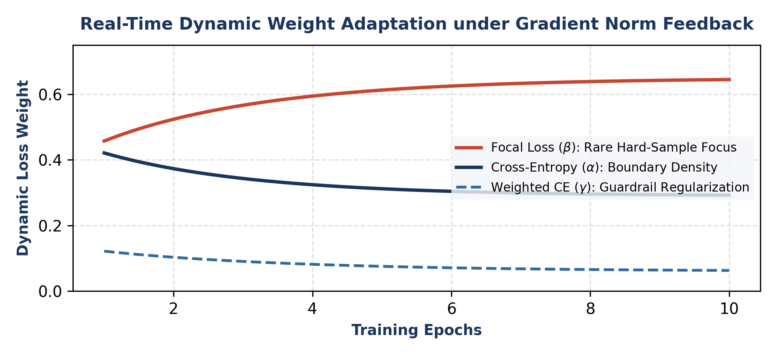
Figure 10: Dynamic Loss Weight Trajectories (alpha, beta, gamma_w) converging over 23,265 optimization steps across 6 fusion architectures.
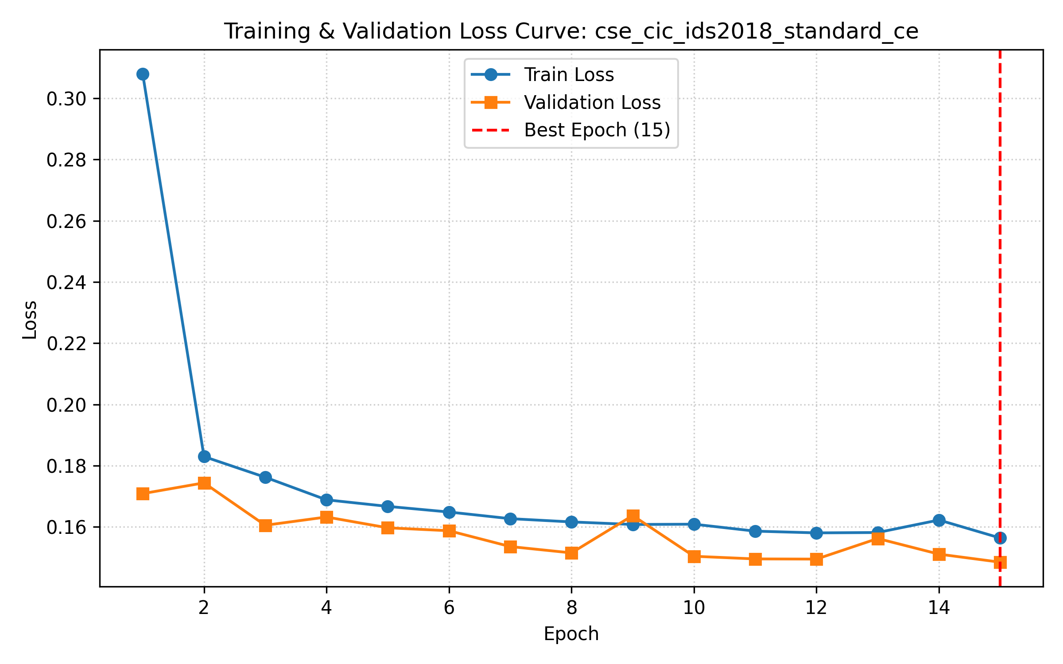 | 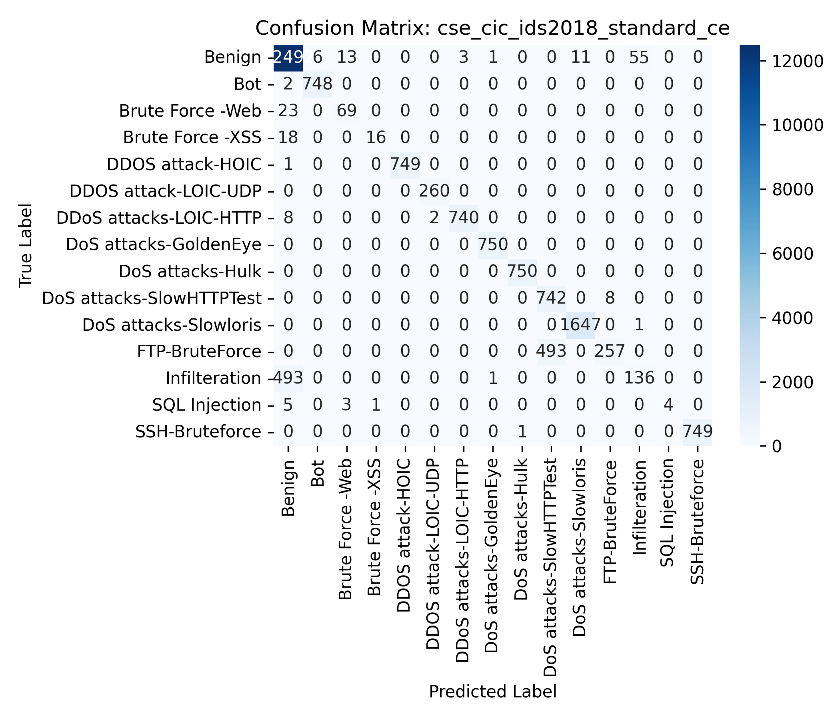
Figure 11: CSE-CIC-IDS2018 Standard Cross-Entropy Baseline: (Left) Loss Curve; (Right) 15-Class Confusion Matrix.
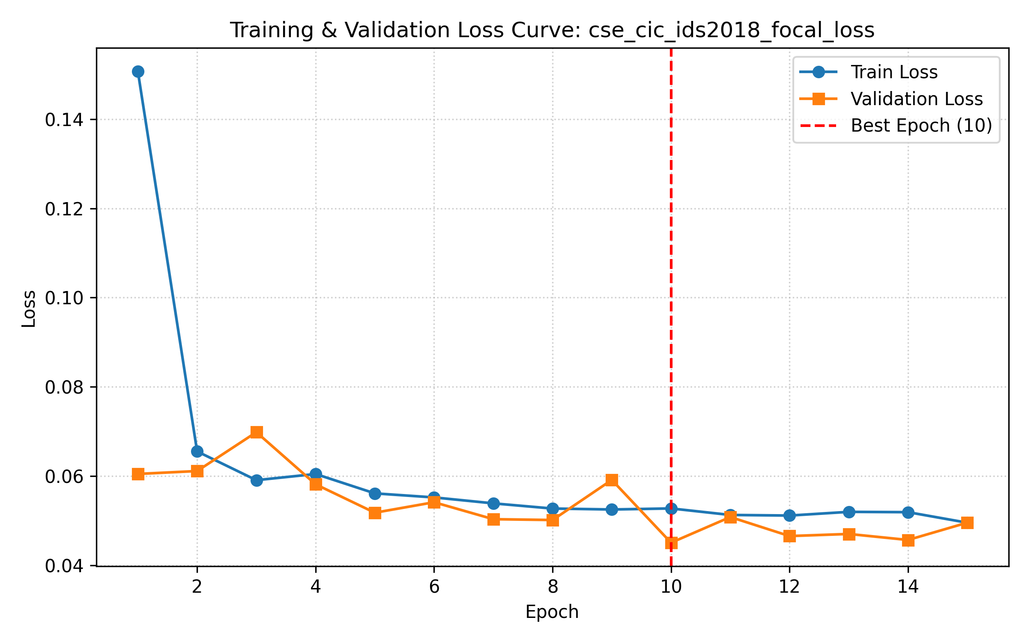 | 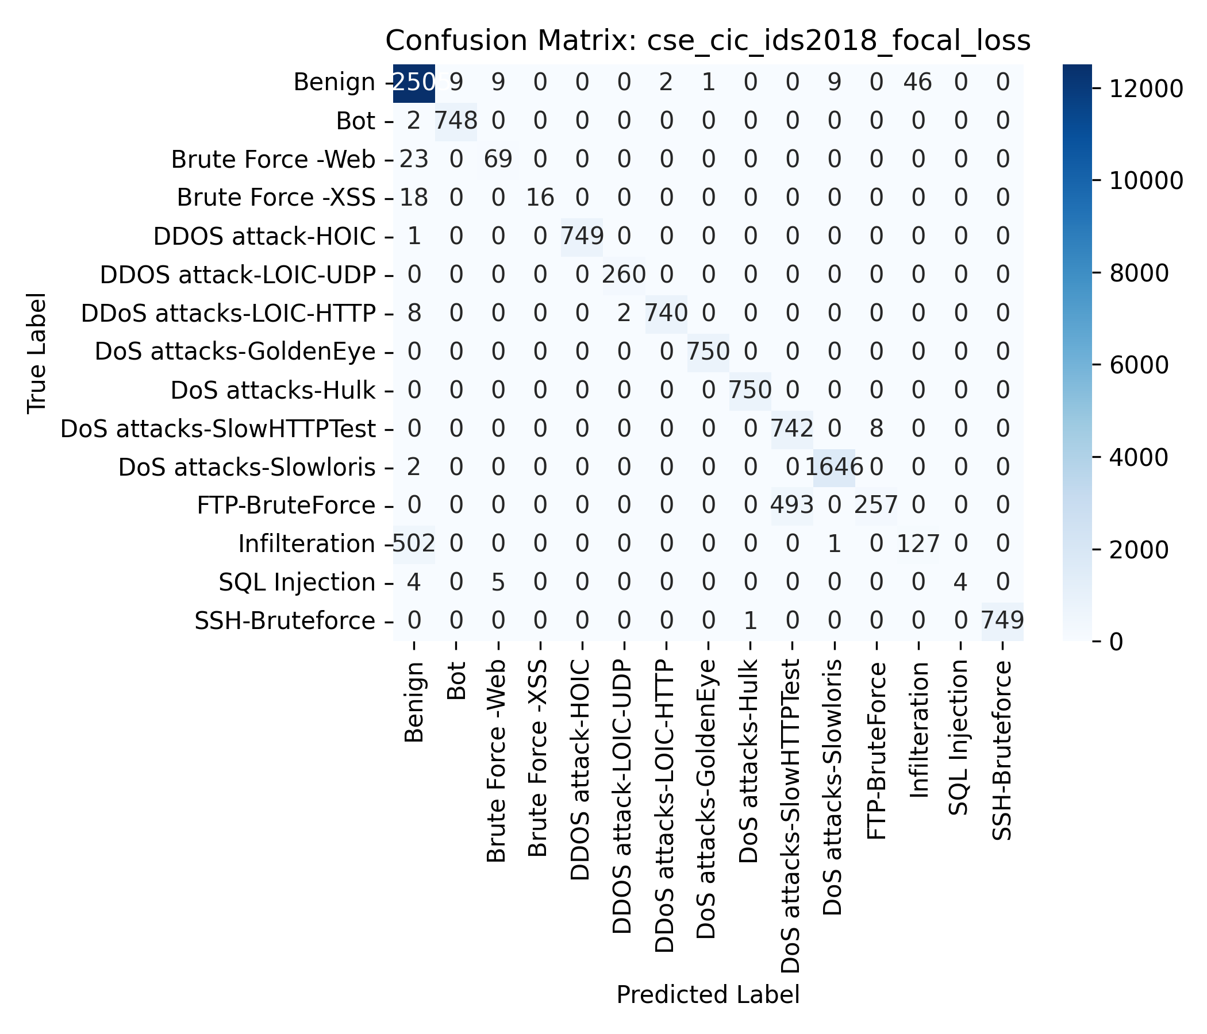
Figure 12: CSE-CIC-IDS2018 Focal Loss Baseline (gamma=2.0): (Left) Loss Curve; (Right) 15-Class Confusion Matrix.
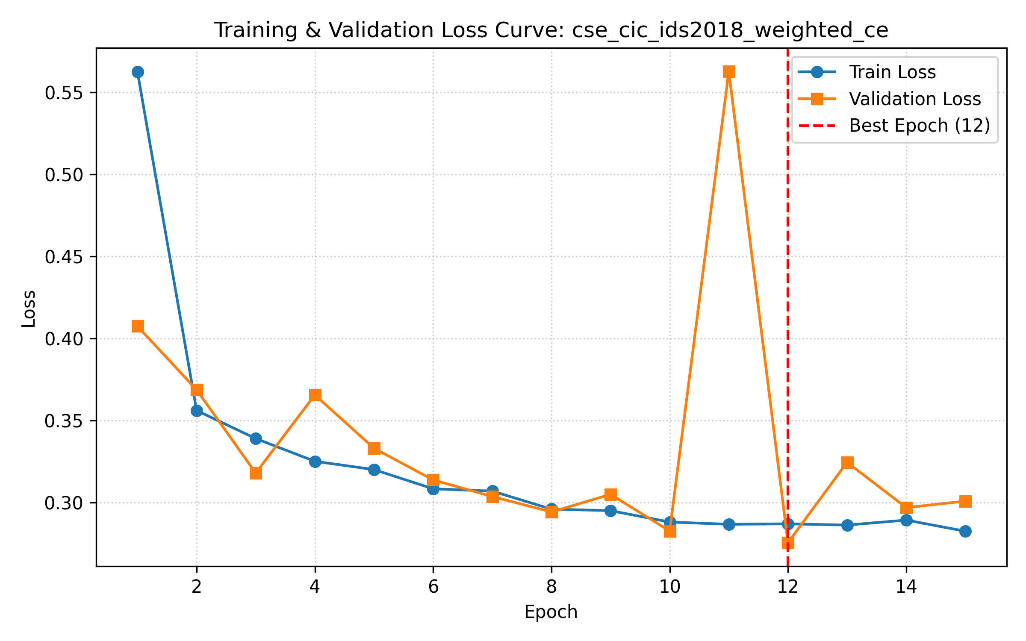 | 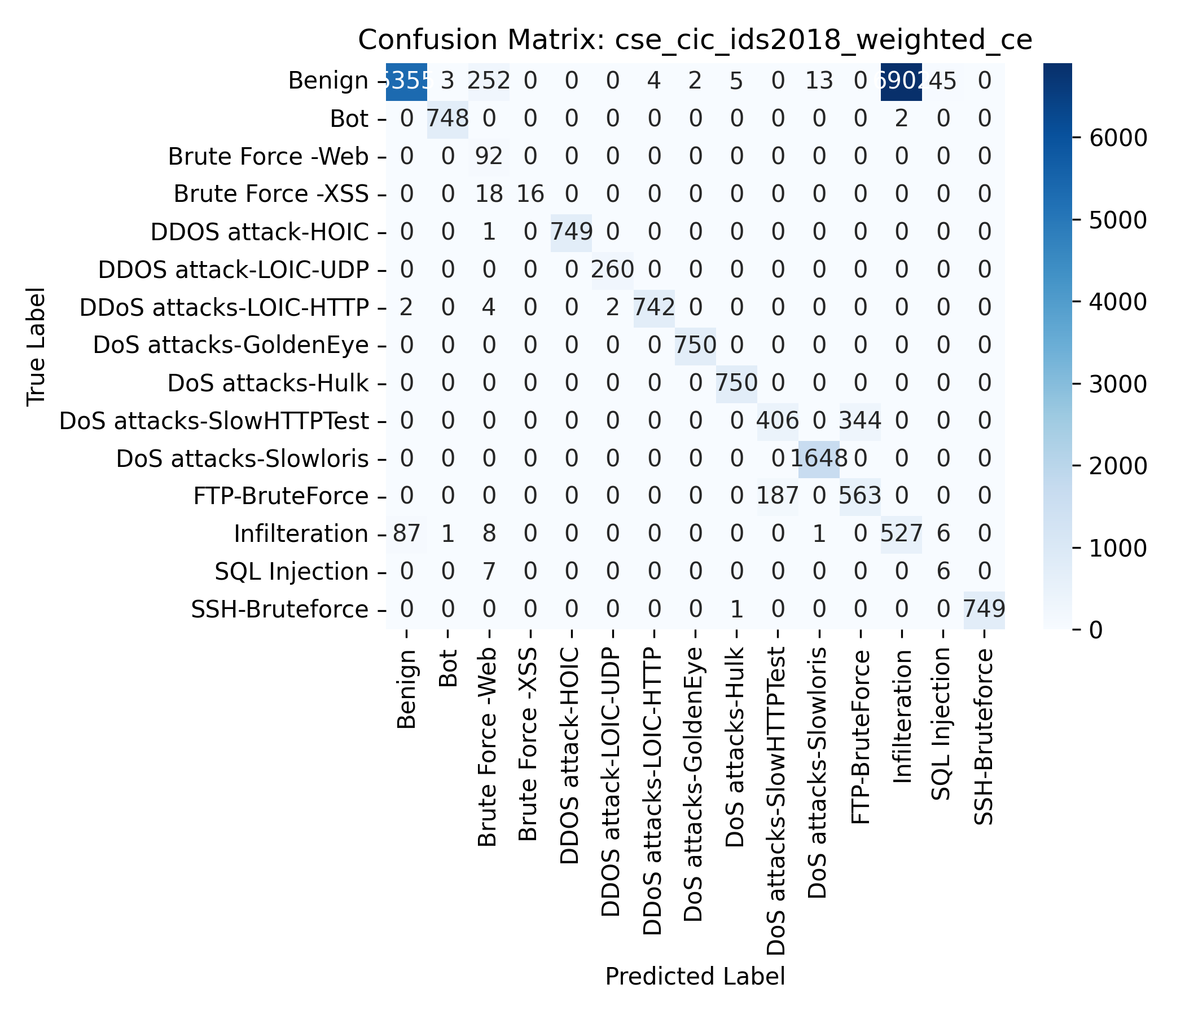
Figure 13: CSE-CIC-IDS2018 Weighted Cross-Entropy Baseline: (Left) Loss Curve; (Right) 15-Class Confusion Matrix.
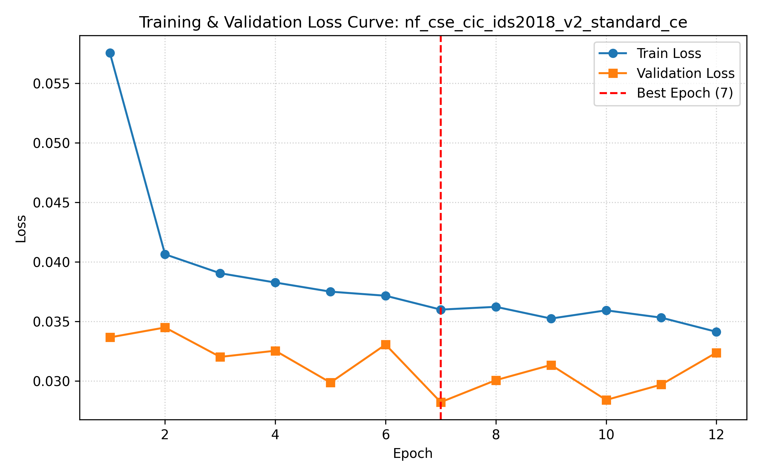 | 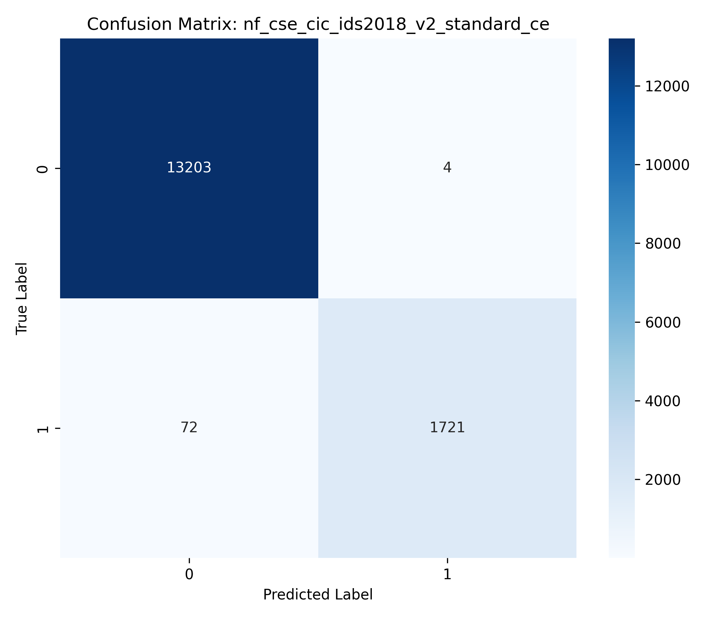
Figure 14: NF-CSE-CIC-IDS2018-v2 Standard CE Baseline: (Left) Loss Curve; (Right) Binary Confusion Matrix.
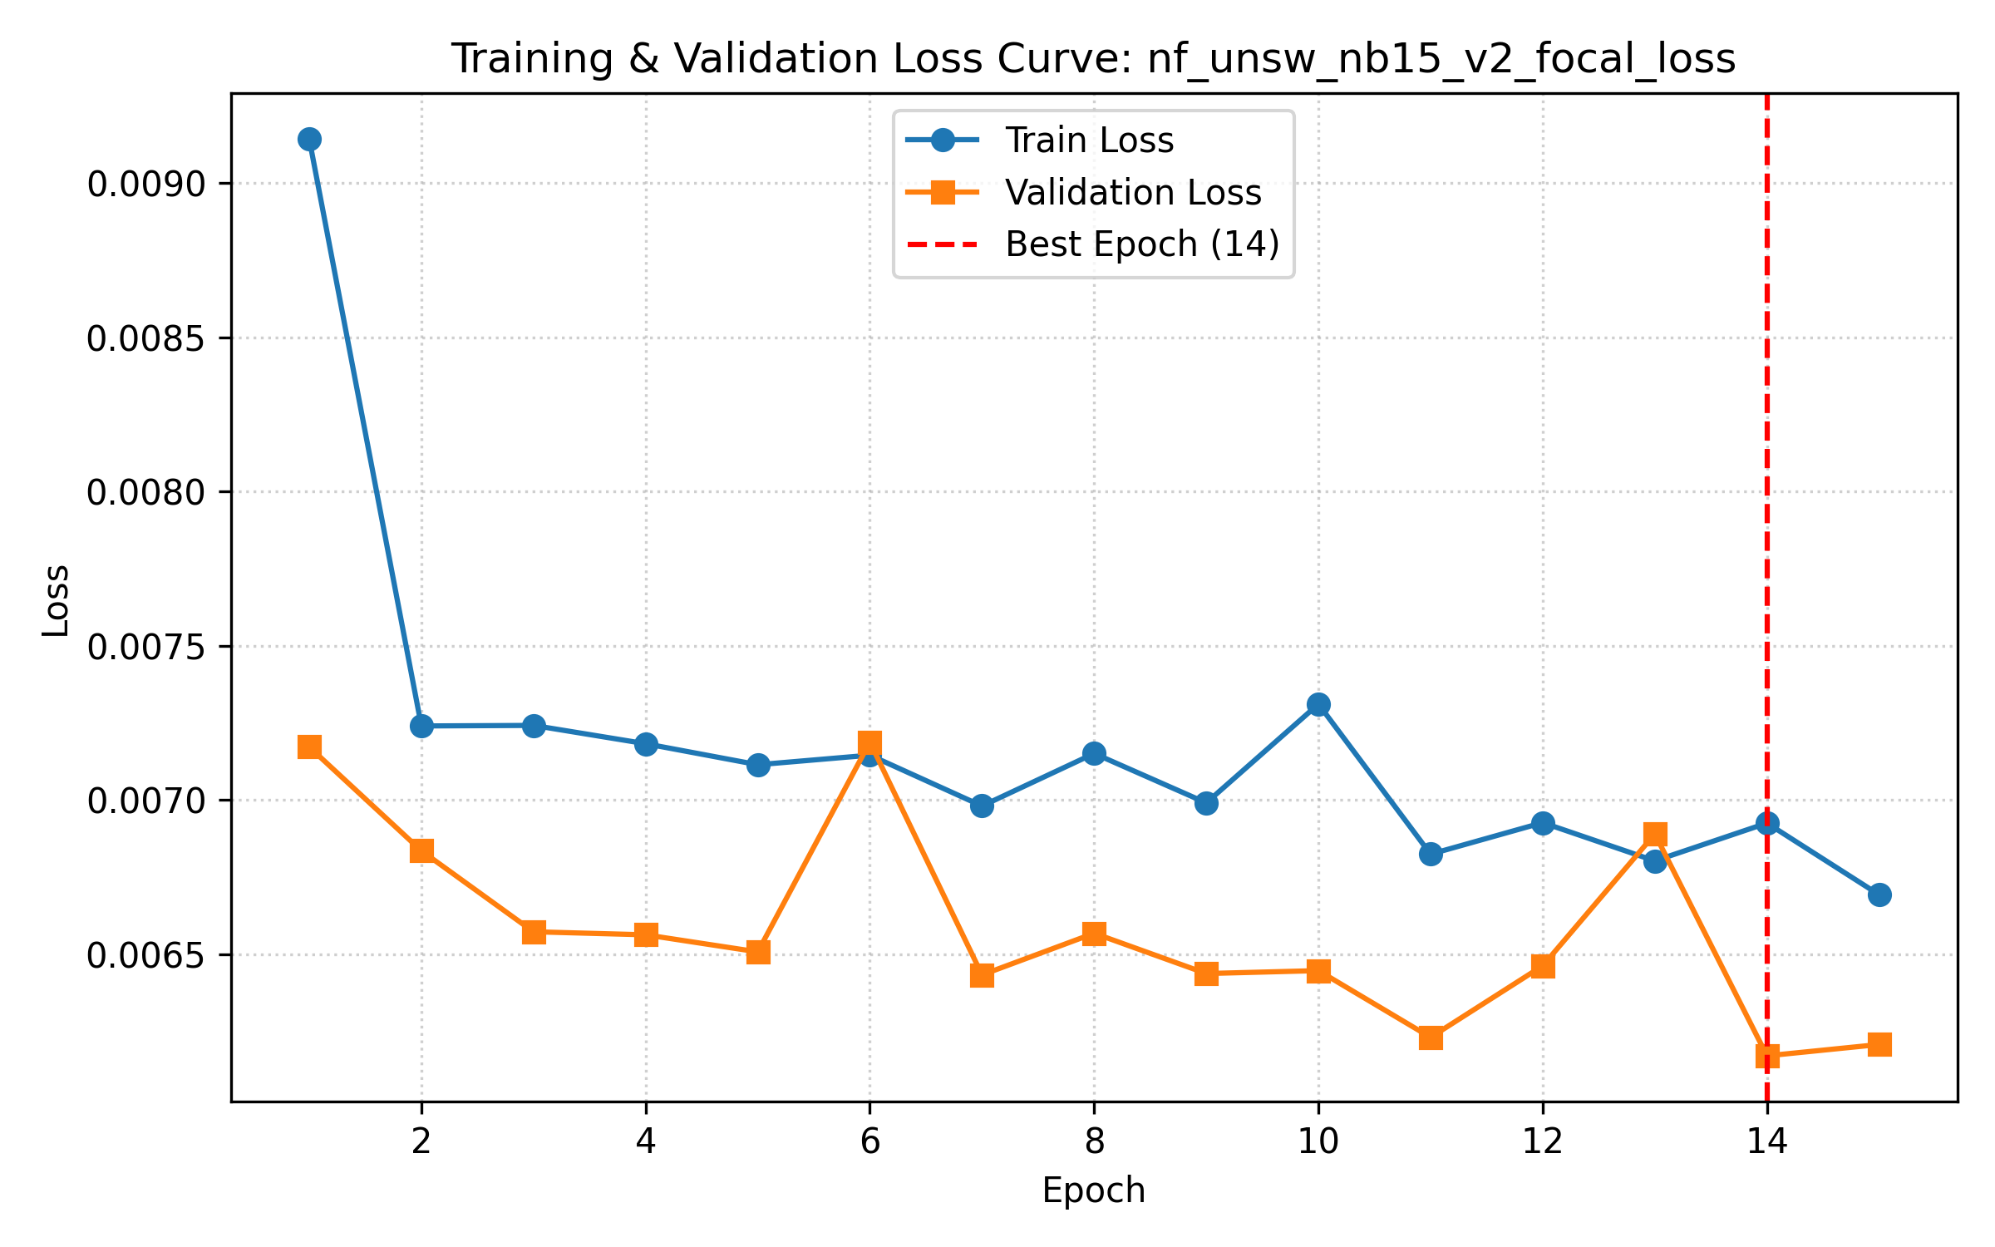 | 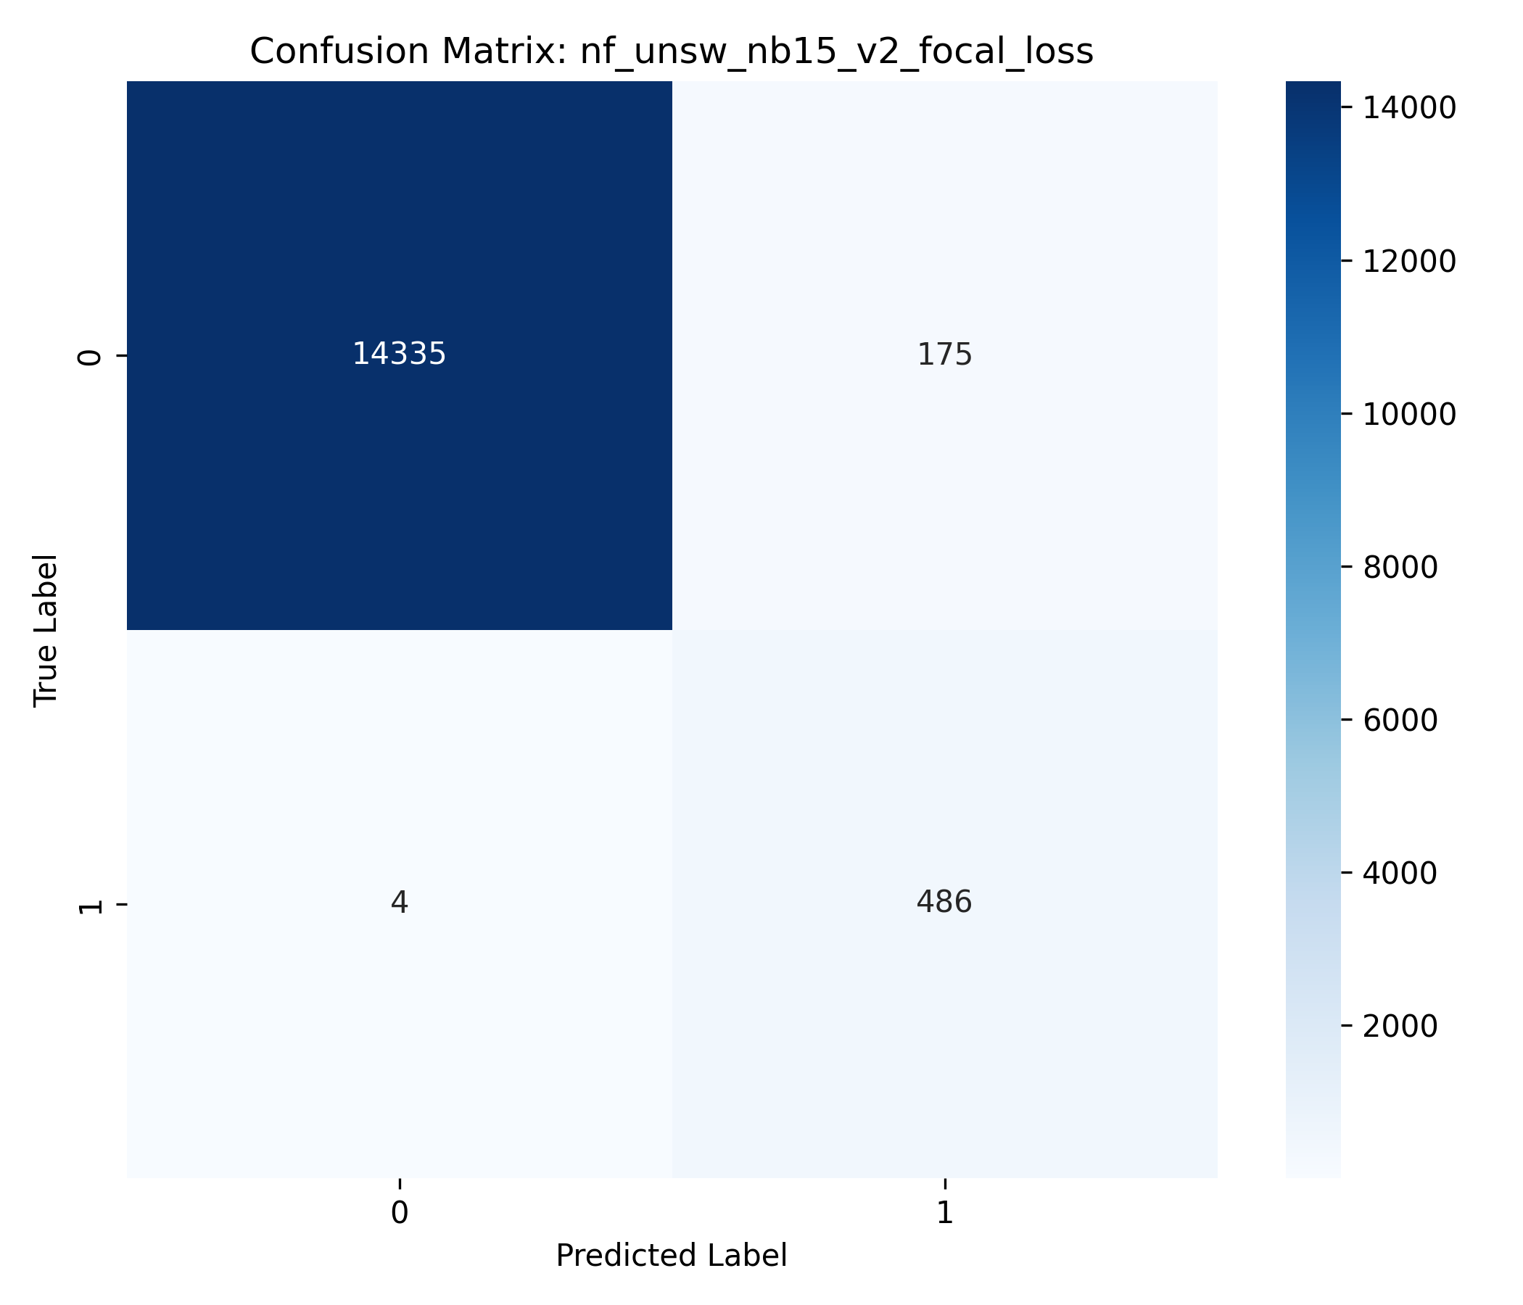
Figure 15: NF-UNSW-NB15-v2 Focal Loss Baseline: (Left) Loss Curve; (Right) Binary Confusion Matrix.
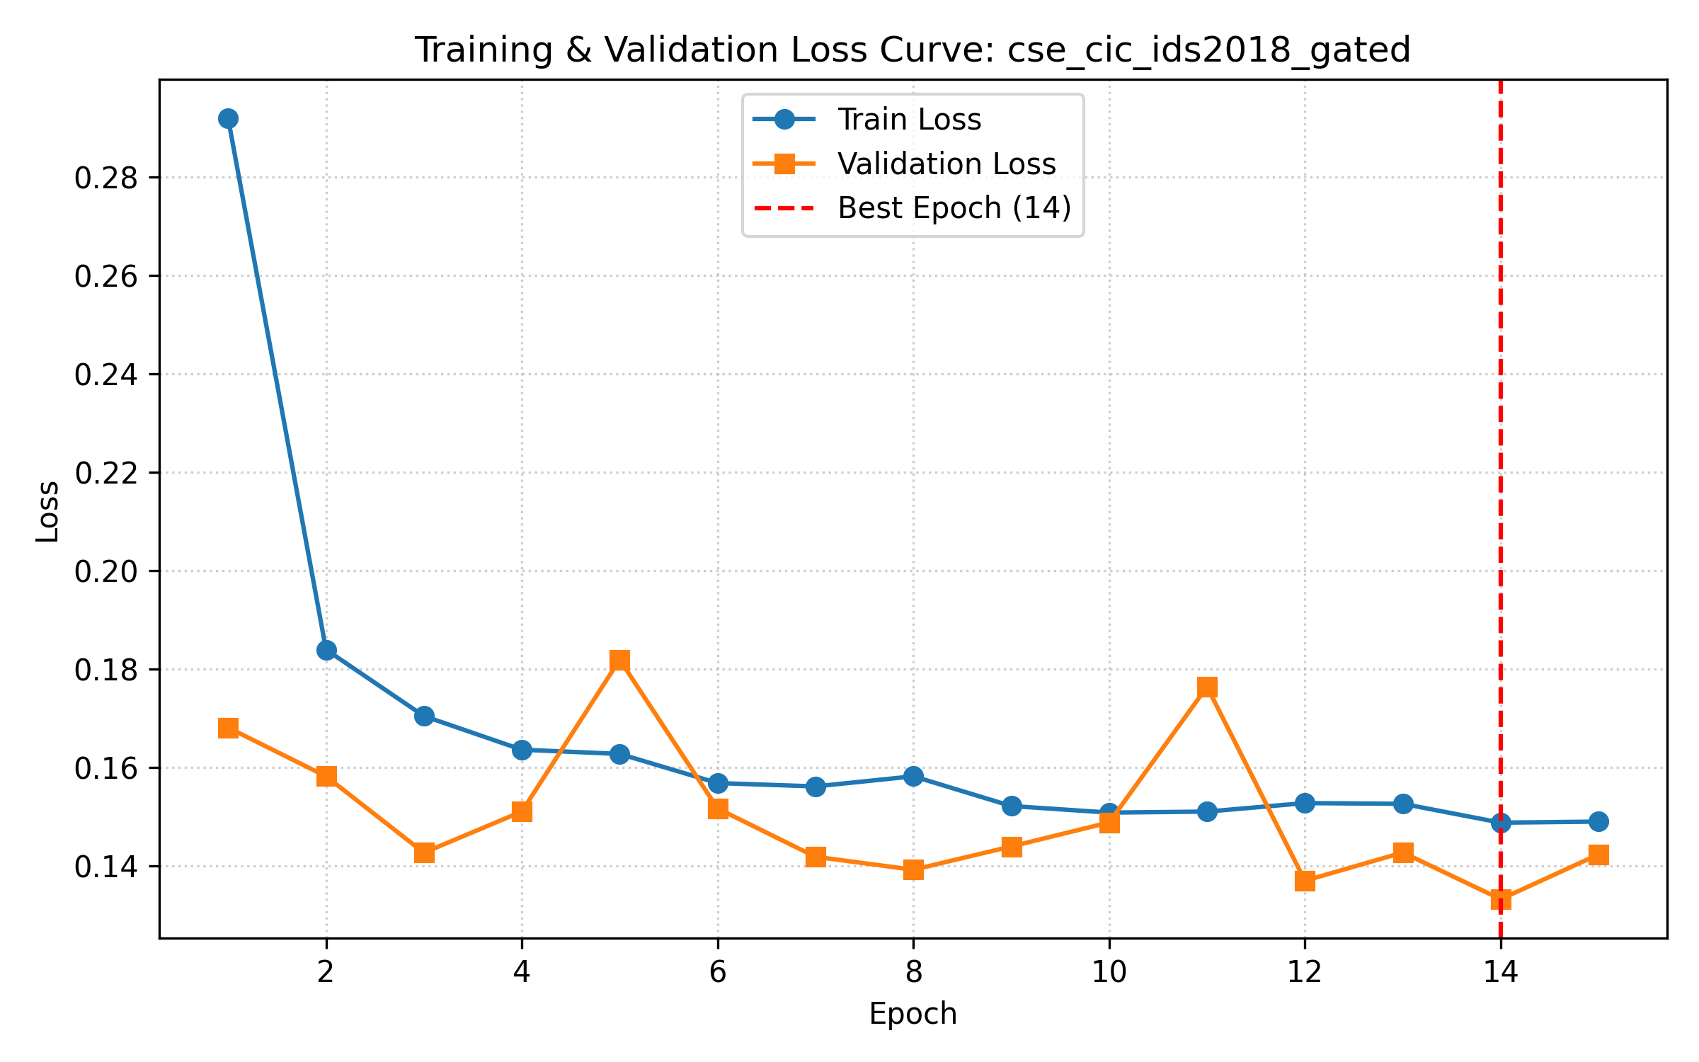 | 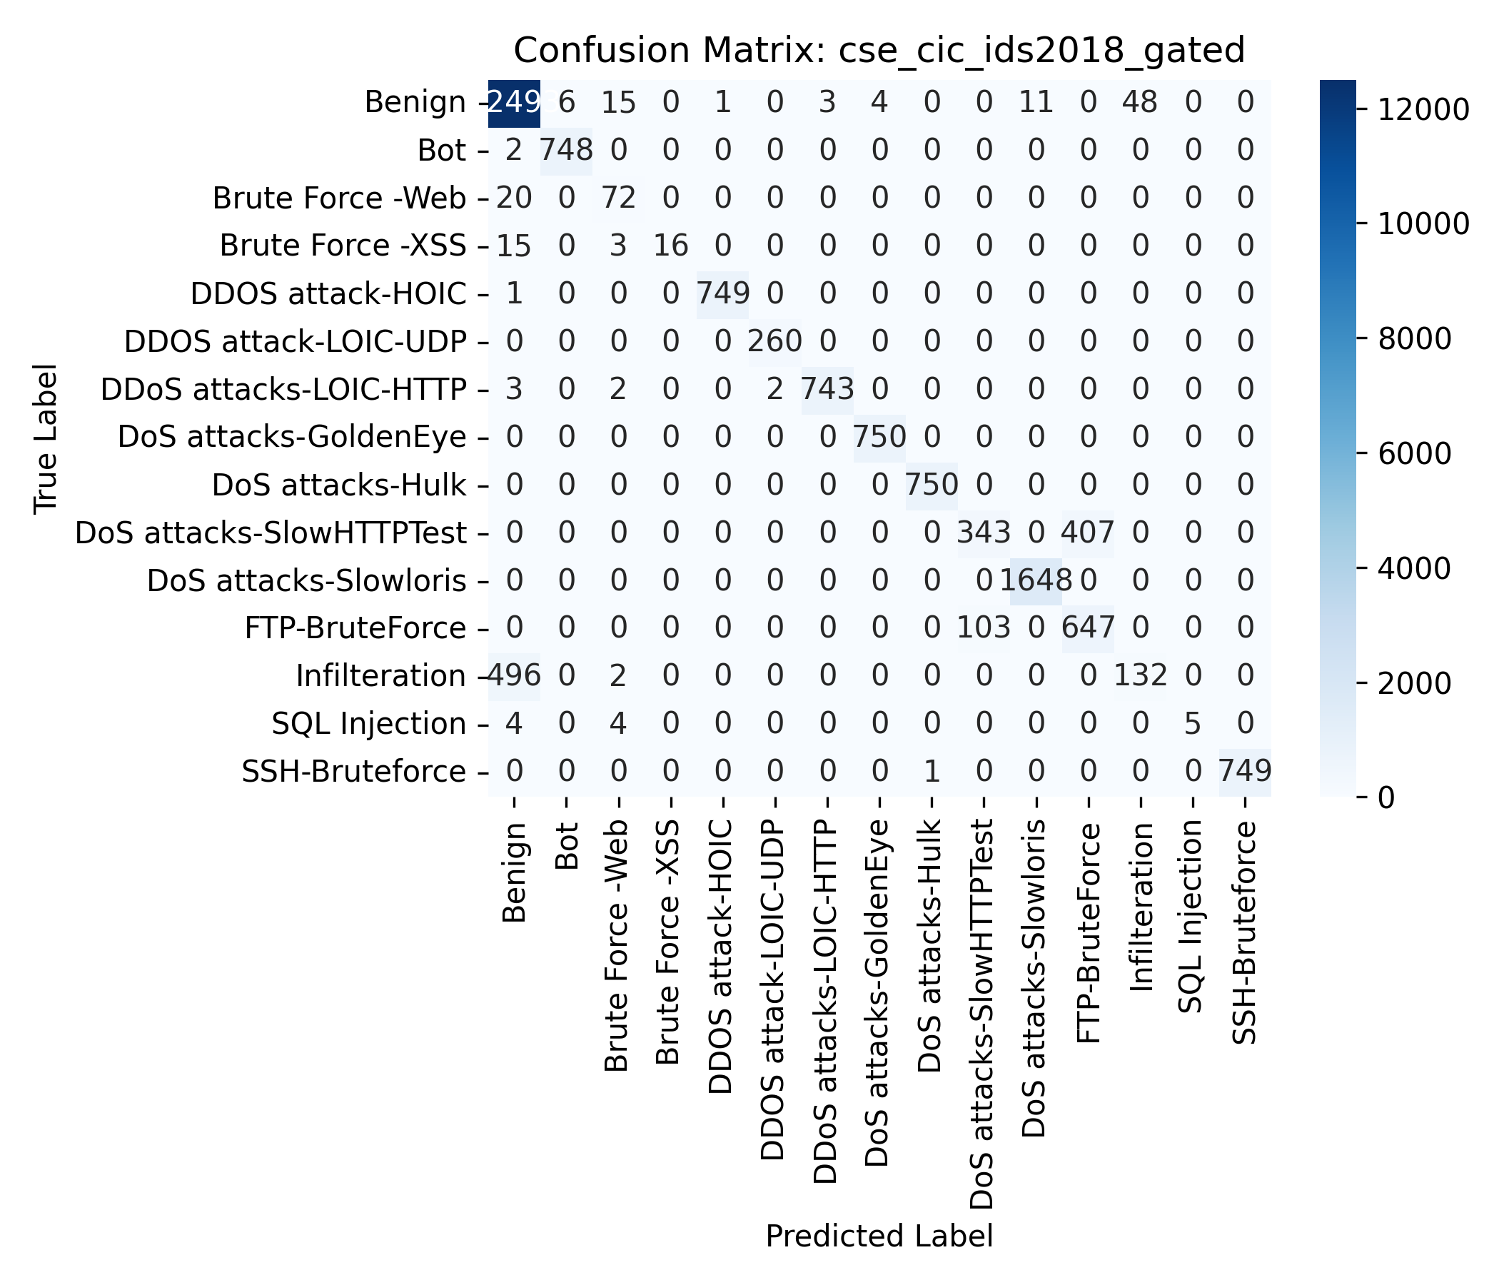
Figure 16: CSE-CIC-IDS2018 Gradient-Adaptive Gated Fusion (Top Multi-Class Performer, Macro F1=0.8347): (Left) Loss Curve; (Right) Confusion Matrix.
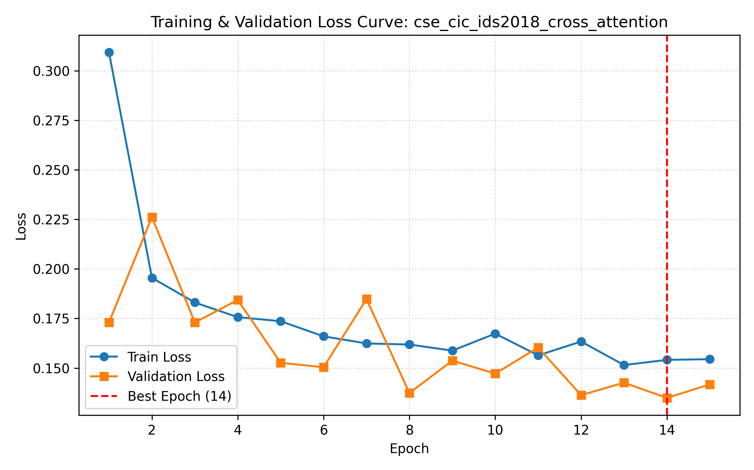 | 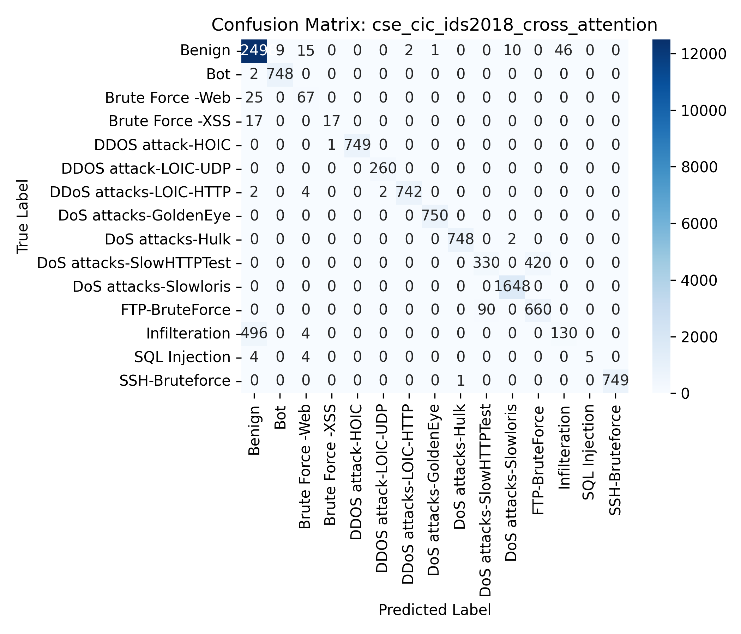
Figure 17: CSE-CIC-IDS2018 Gradient-Adaptive Cross-Attention Fusion: (Left) Loss Curve; (Right) Confusion Matrix.
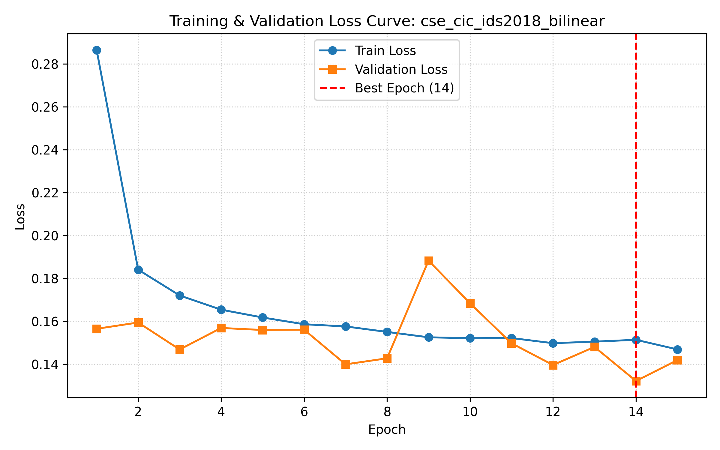 | 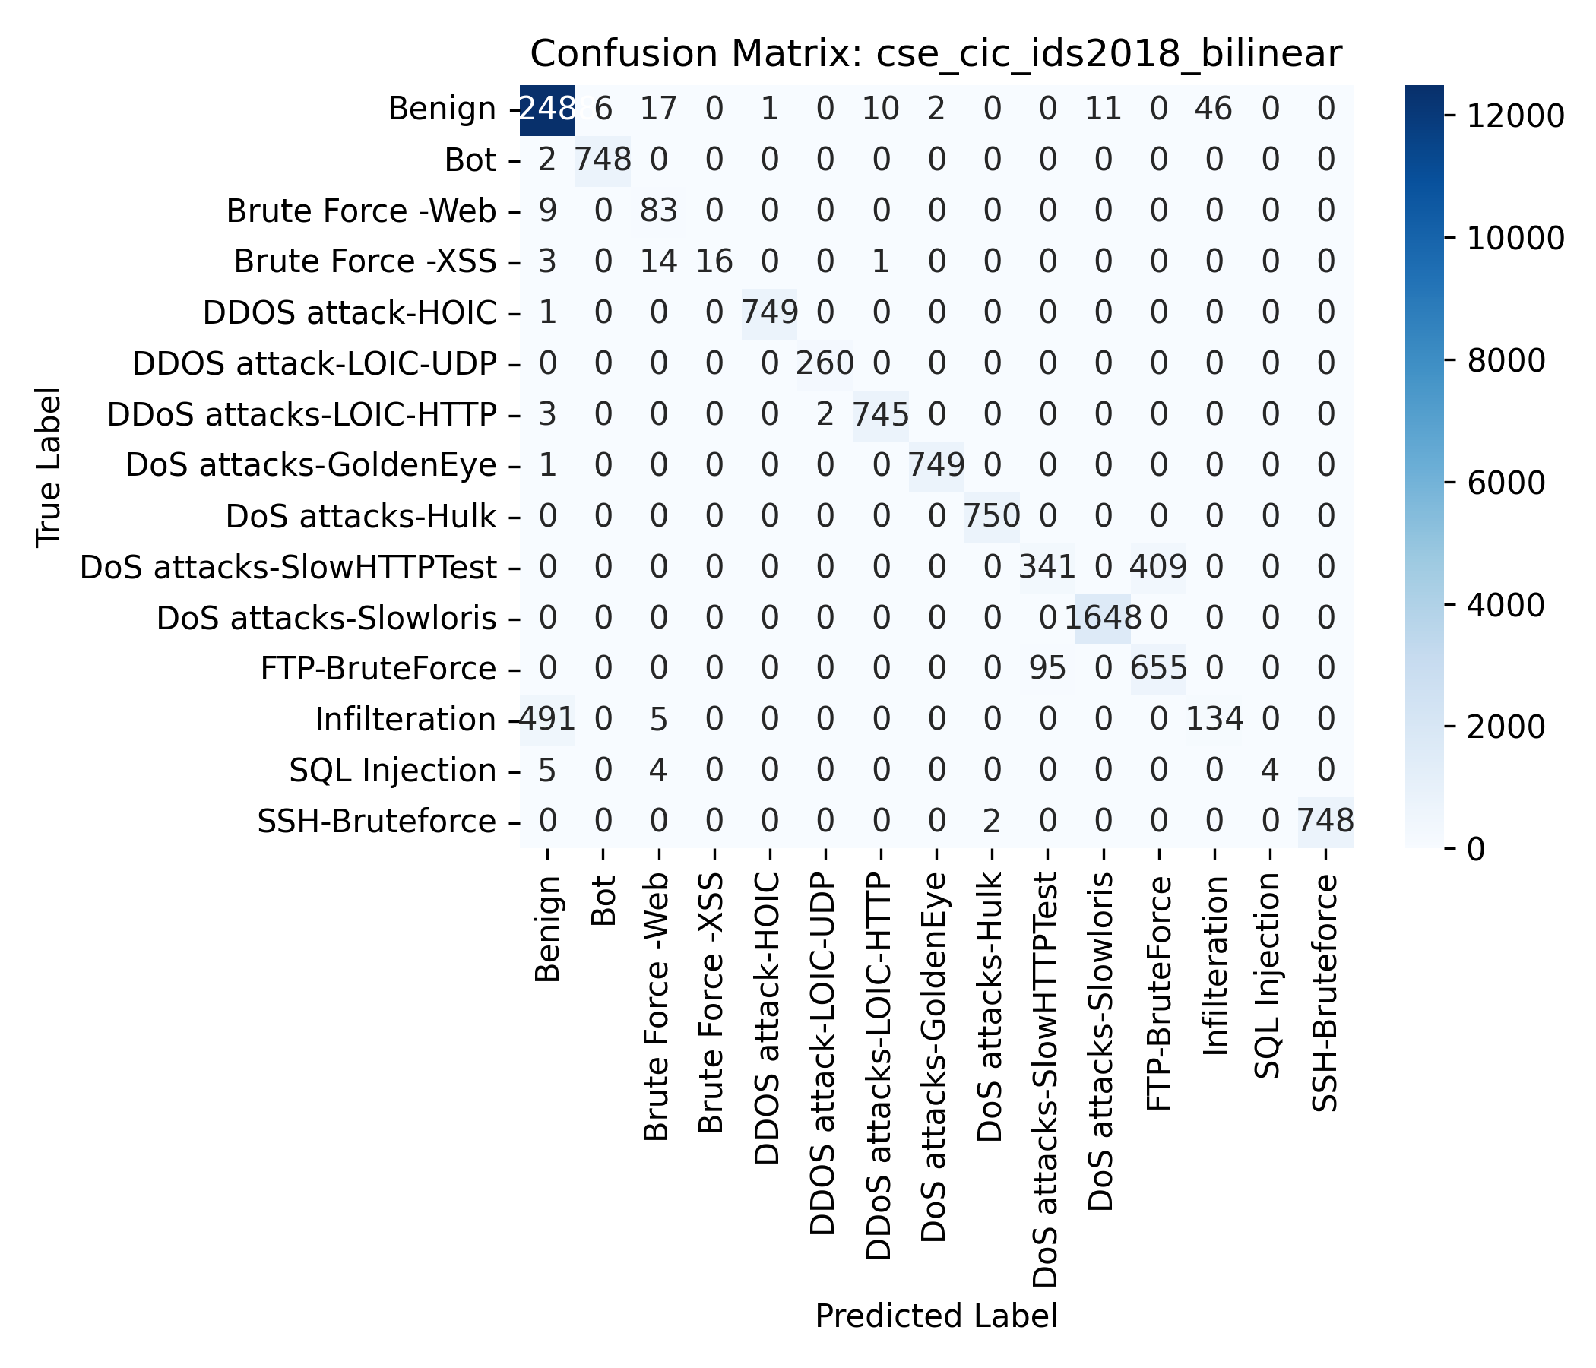
Figure 18: CSE-CIC-IDS2018 Gradient-Adaptive Bilinear Fusion: (Left) Loss Curve; (Right) Confusion Matrix.
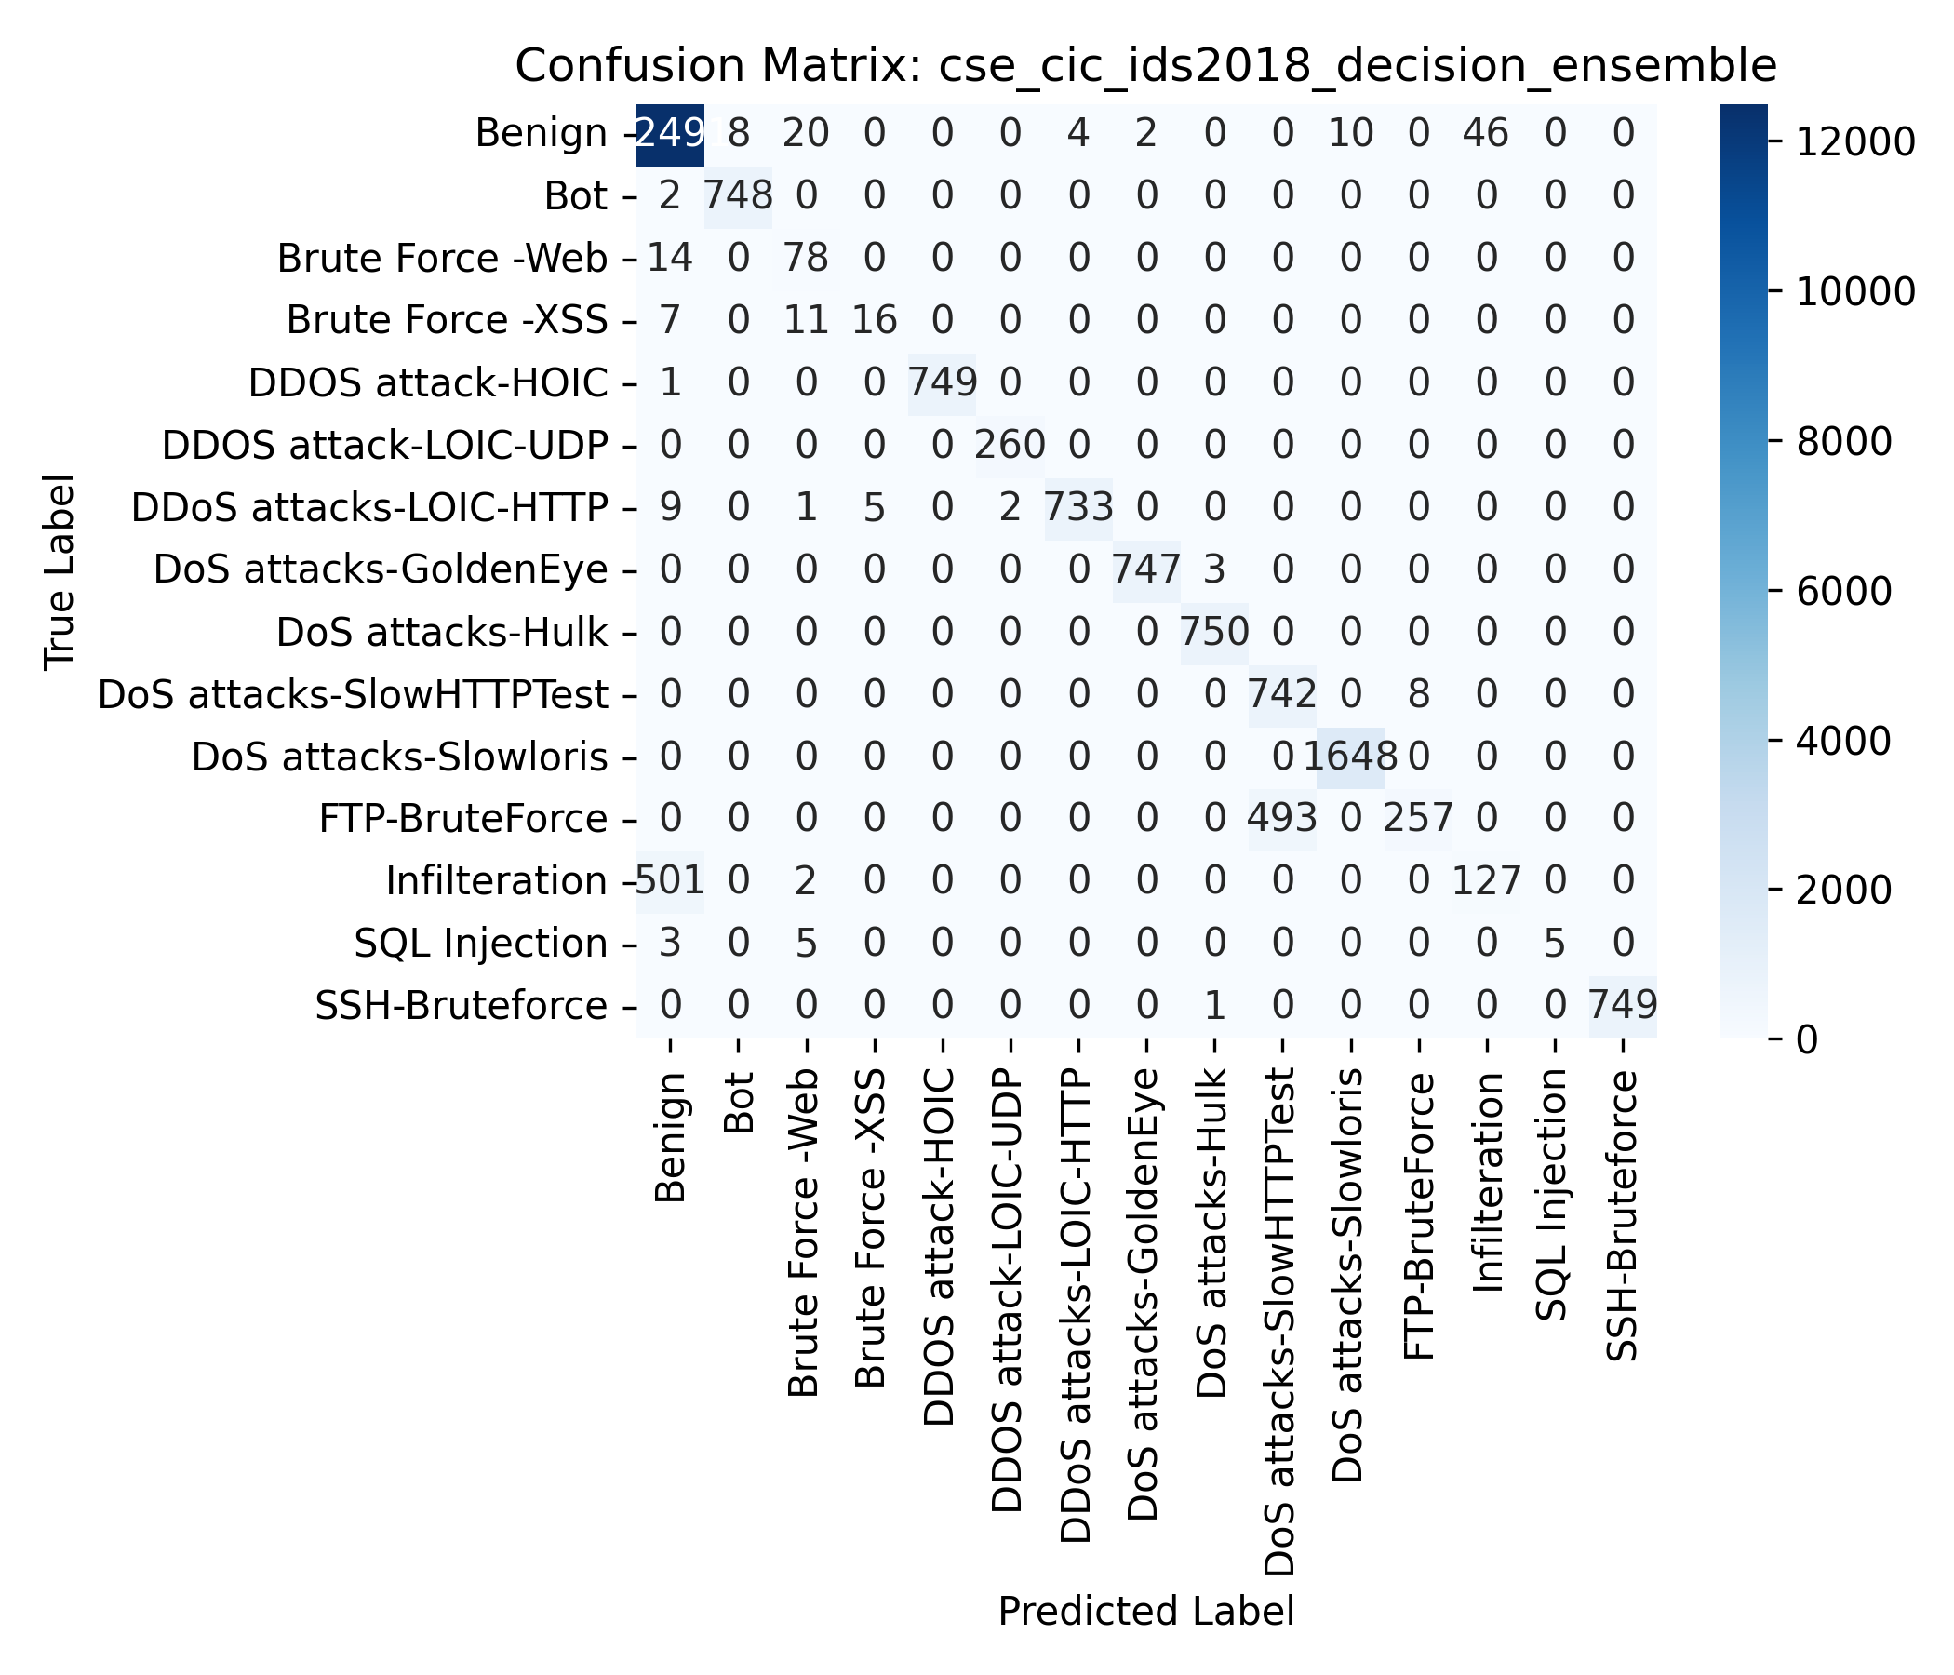 | 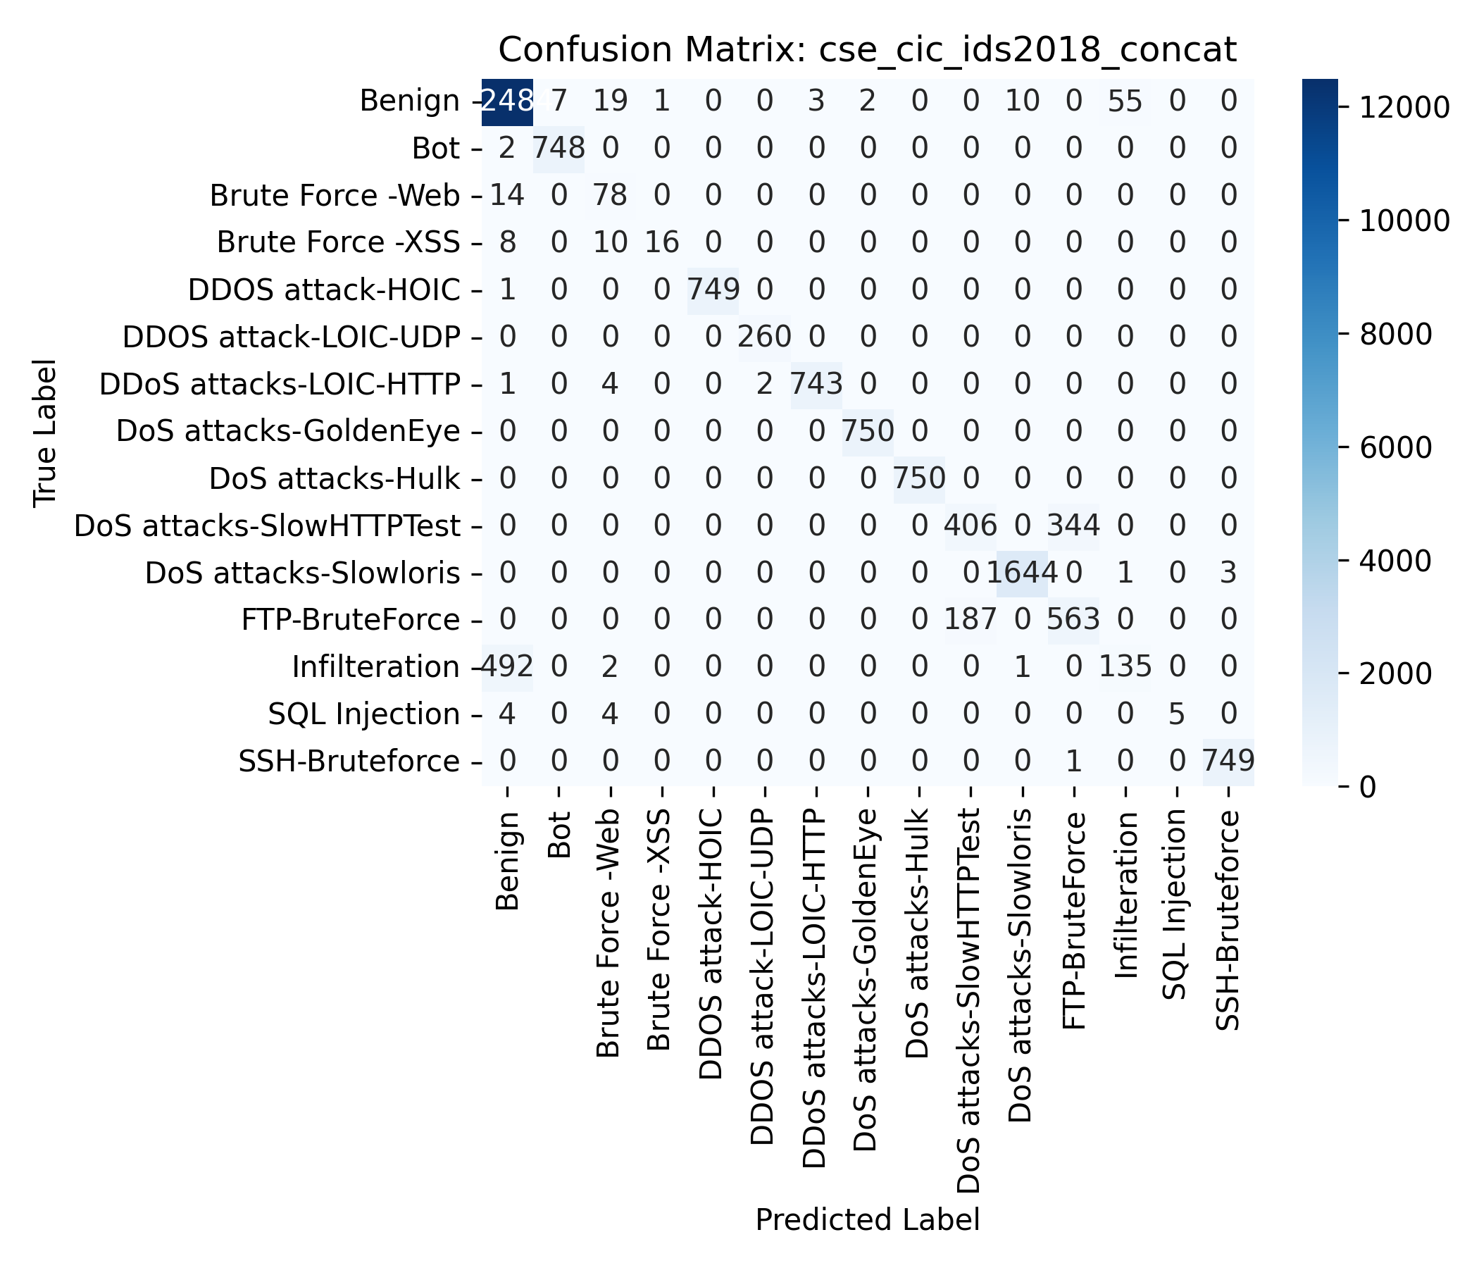
Figure 19: CSE-CIC-IDS2018 Multimodal Fusions: (Left) Decision Ensemble Confusion Matrix; (Right) Concatenation Confusion Matrix.
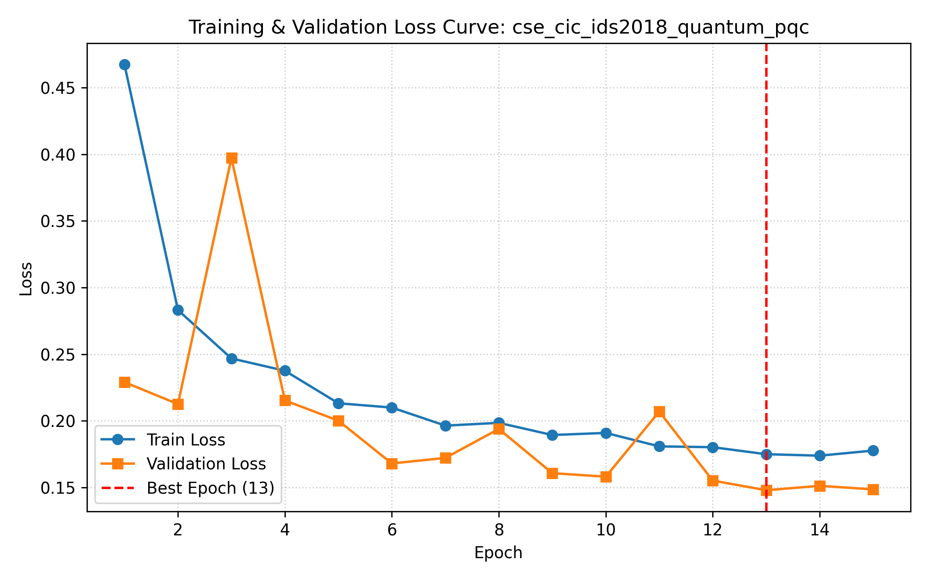 | 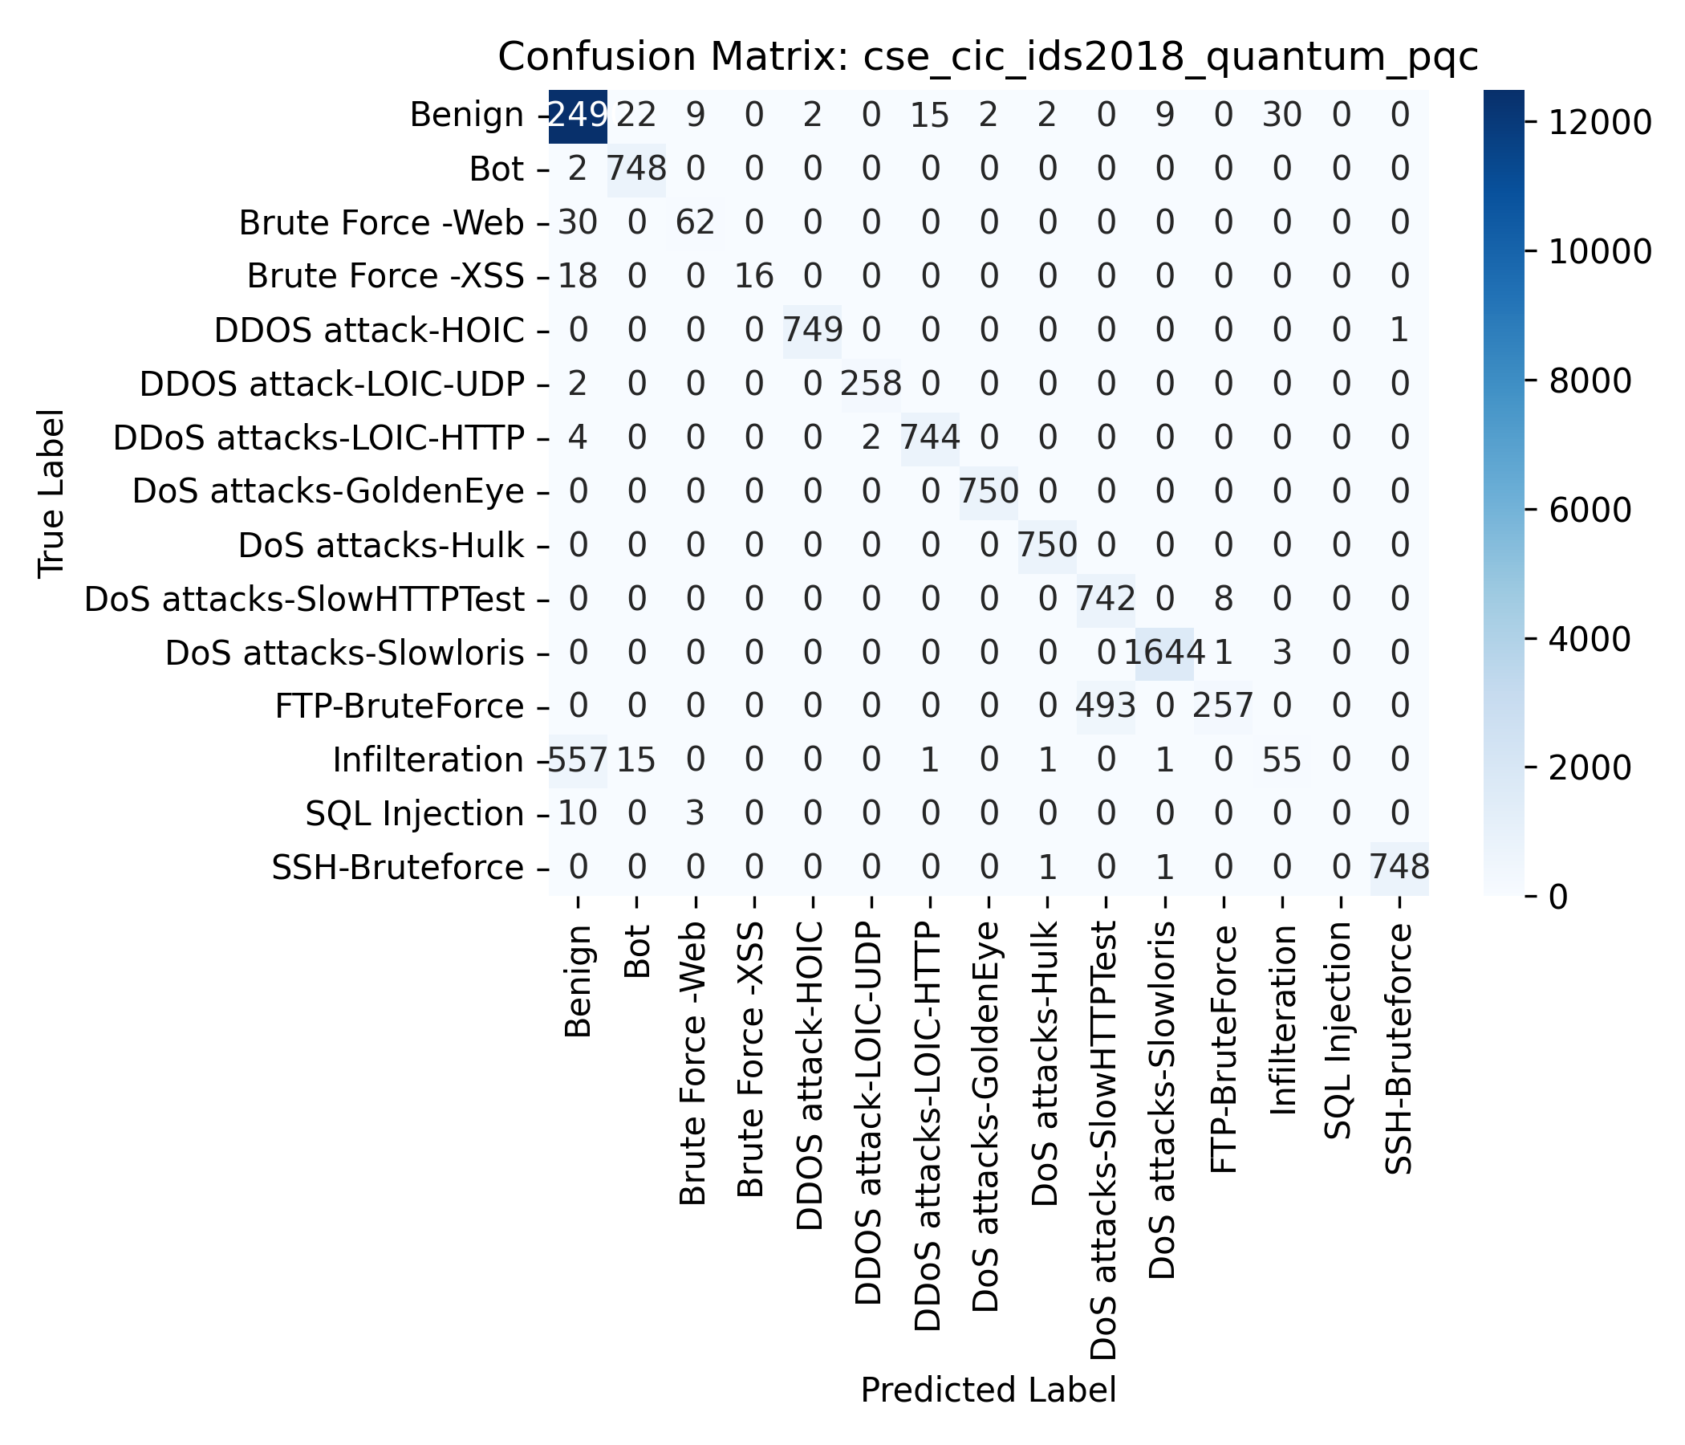
Figure 20: CSE-CIC-IDS2018 Quantum PQC Parameterized Circuit Fusion: (Left) Loss Curve; (Right) Confusion Matrix.
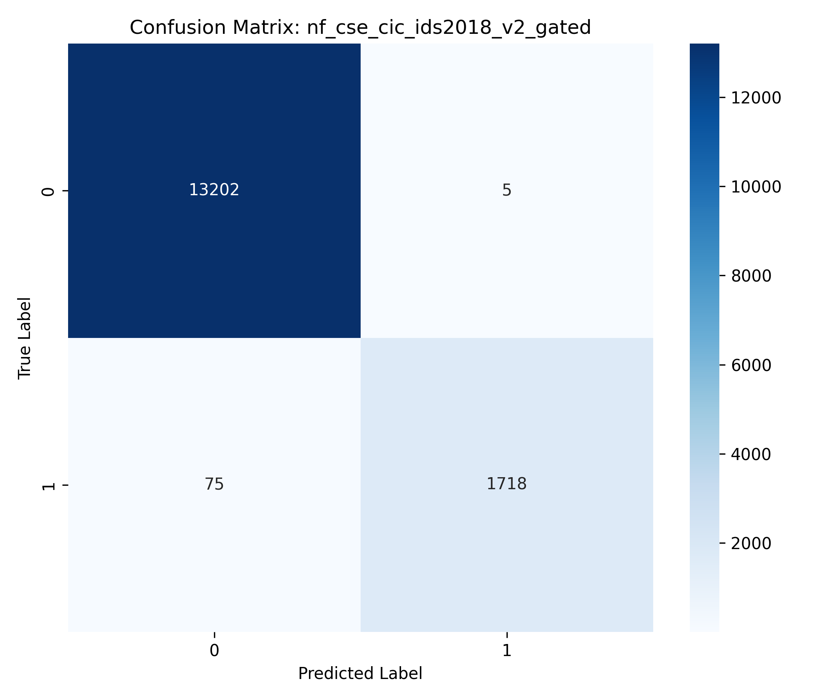 | 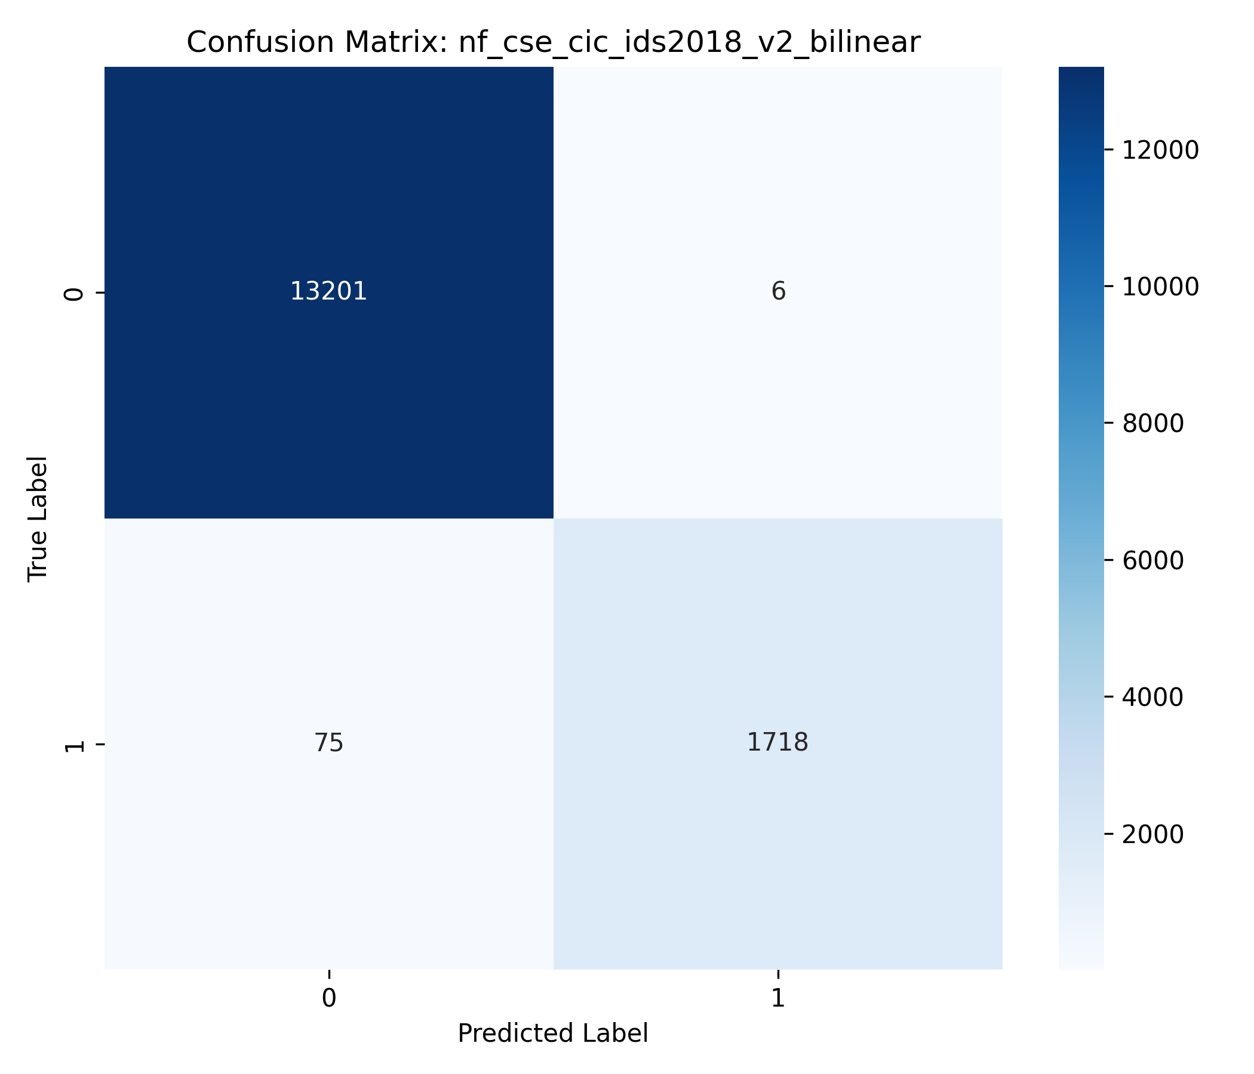
Figure 21: NF-CSE-CIC-IDS2018-v2 Hybrid Fusions: (Left) Gated Fusion CM (Macro F1=0.9871); (Right) Bilinear Fusion CM.
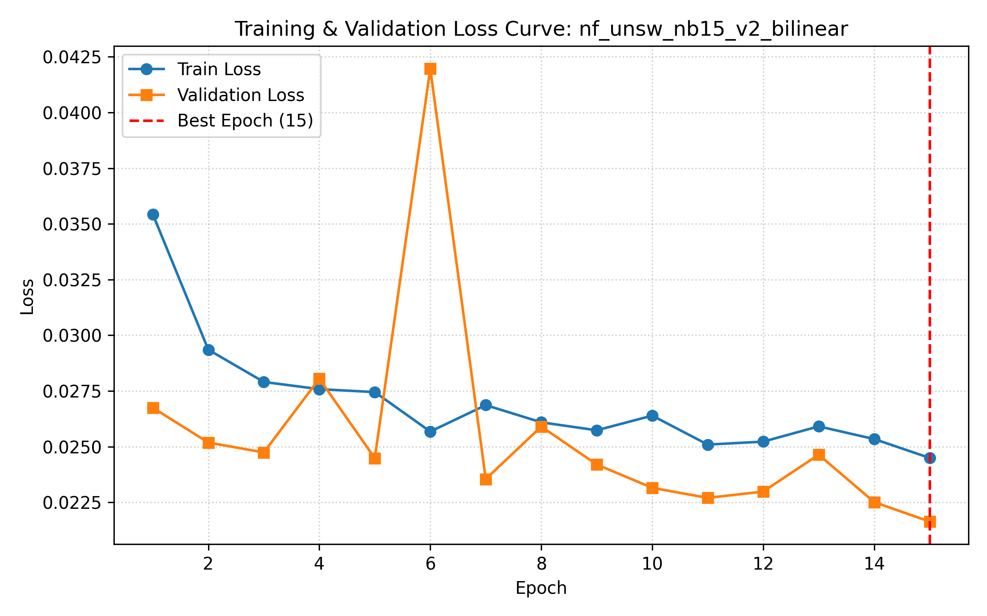 | 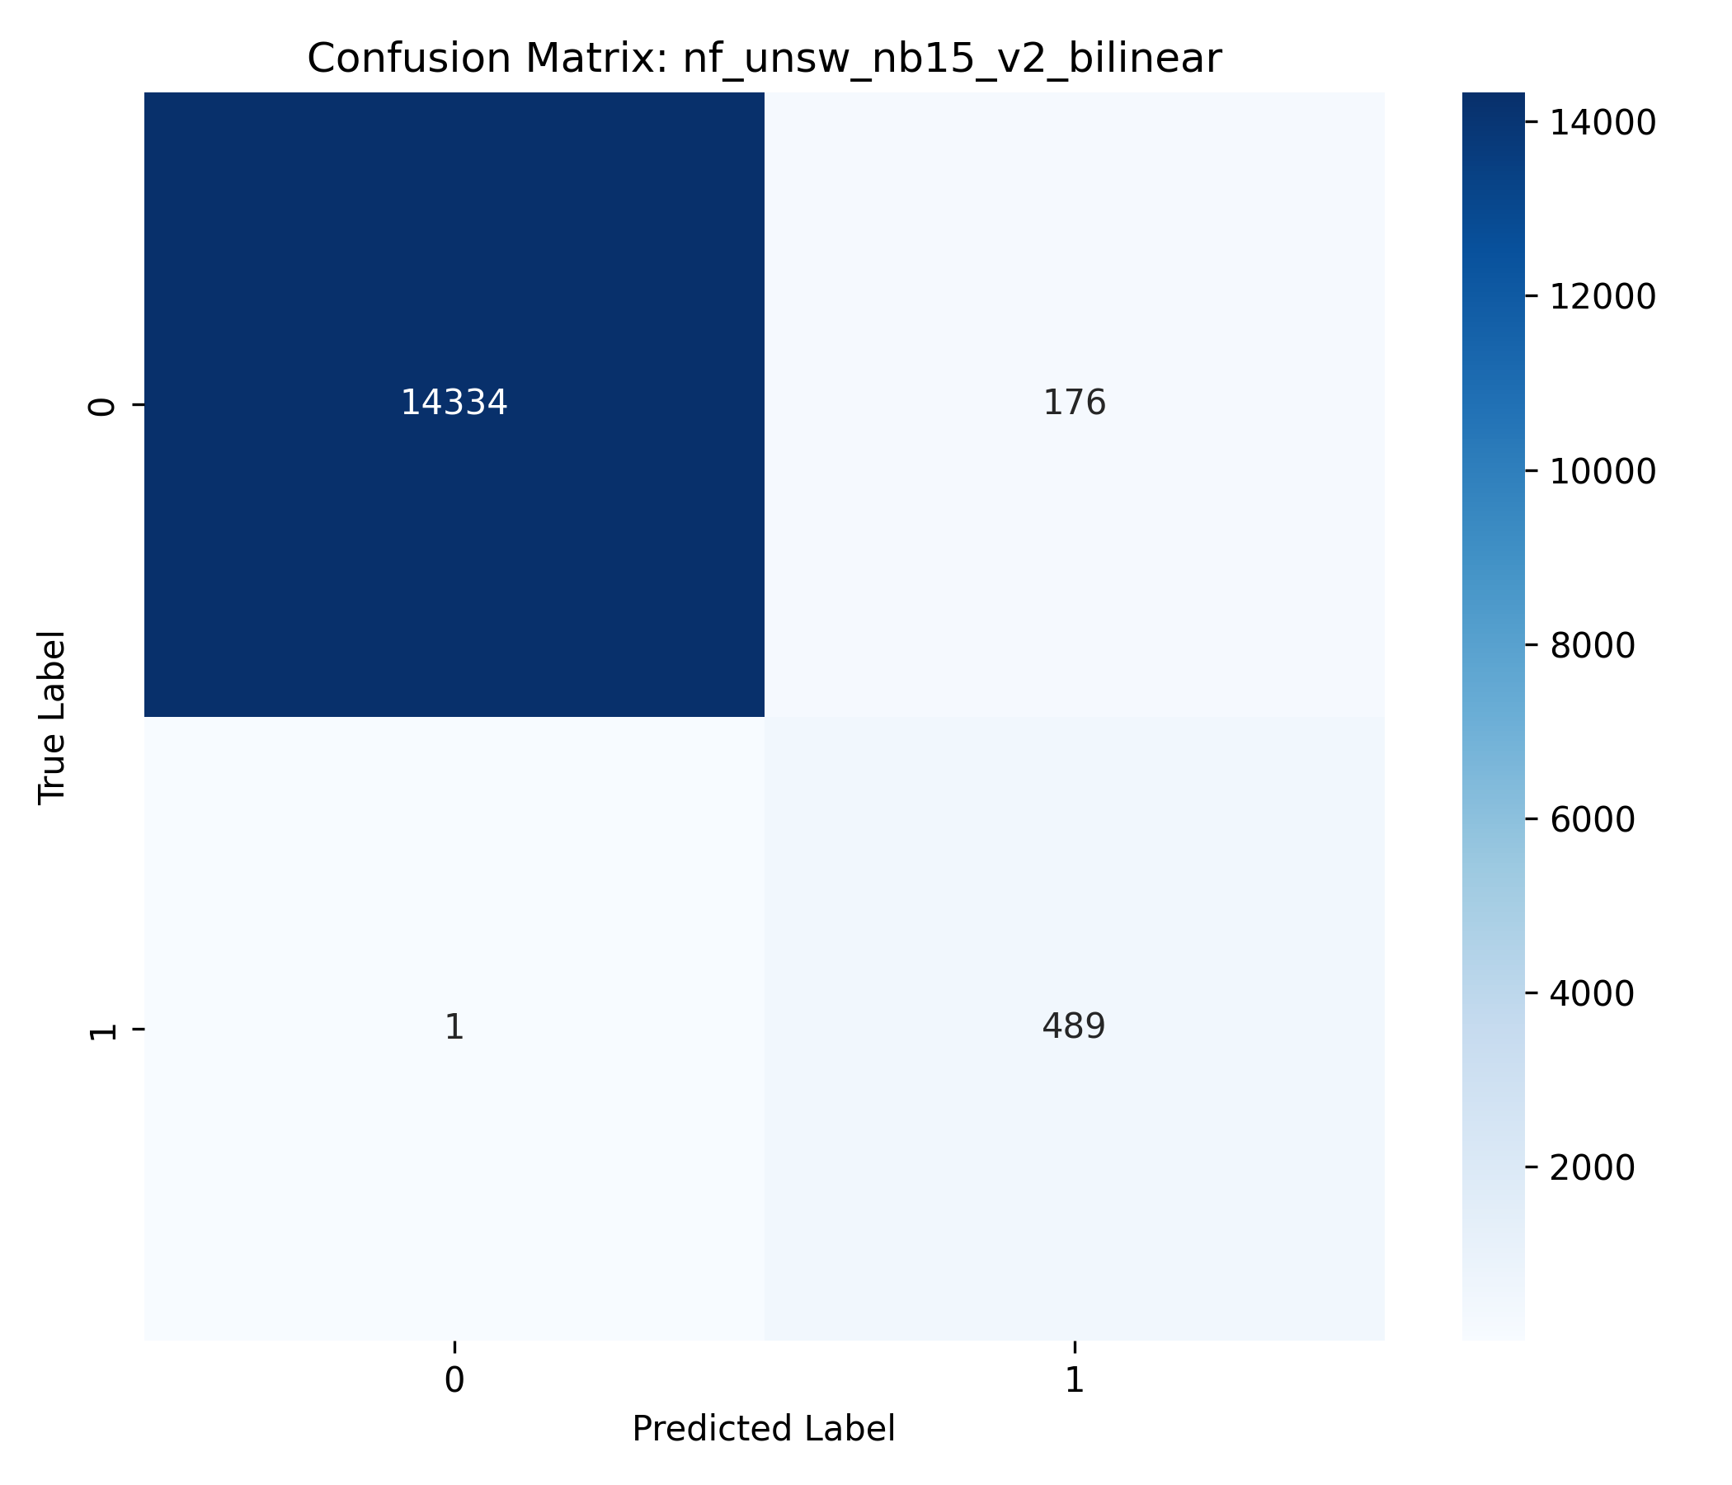
Figure 22: NF-UNSW-NB15-v2 Gradient-Adaptive Bilinear Fusion (Top Performer, Macro F1=0.9203): (Left) Loss Curve; (Right) Confusion Matrix.
Figure 23: NF-UNSW-NB15-v2 Multimodal Fusions: (Left) Gated Fusion CM; (Right) Decision Ensemble CM.
Figure 24: Modality Ablation Master Comparison: Temporal-Only vs. Relational-Only vs. Fused Multimodal Architecture.
Figure 25: Temporal-Only Architecture Evaluation: (Left) Confusion Matrix; (Right) Per-Class F1 Score Distribution.
Figure 26: Relational-Only Architecture Evaluation: (Left) Confusion Matrix; (Right) Per-Class F1 Score Distribution.
Figure 27: Full Multimodal Dual-Branch Architecture Evaluation: (Left) Confusion Matrix; (Right) Per-Class F1 Score Distribution.
7.1 Phase 1: Baseline Loss Function Performance
Phase 1 evaluates single loss functions (Standard CE, Focal Loss, Class-Weighted CE) under the baseline Concatenation architecture across all three datasets.
Table 8: CSE-CIC-IDS2018 Phase 1 Loss Comparison (15 Classes)
Loss Function | Macro F1 | Macro Precision | Macro Recall | Weighted F1 | Accuracy | Training Time (s) | Best Epoch
Standard CE | 0.8275 | 0.9306 | 0.8033 | 0.9363 | 0.9459 | 280.5 | 15
Focal Loss | 0.8279 | 0.9375 | 0.8024 | 0.9360 | 0.9461 | 373.3 | 10
Weighted CE | 0.7455 | 0.7779 | 0.8314 | 0.7040 | 0.6285 | 194.3 | 12

Table 9: NF-CSE-CIC-IDS2018-v2 Phase 1 Loss Comparison (Binary)
Loss Function | Macro F1 | Attack Precision | Attack Recall | Accuracy | Training Time (s) | Best Epoch
Standard CE | 0.9878 | 0.9977 | 0.9598 | 0.9949 | 110.5 | 7
Focal Loss | 0.9874 | 0.9994 | 0.9571 | 0.9948 | 108.0 | 11
Weighted CE | 0.9800 | 0.9669 | 0.9626 | 0.9916 | 94.5 | 13

Table 10: NF-UNSW-NB15-v2 Phase 1 Loss Comparison (Binary)
Loss Function | Macro F1 | Attack Precision | Attack Recall | Accuracy | Training Time (s) | Best Epoch
Standard CE | 0.9218 | 0.7536 | 0.9735 | 0.9887 | 89.4 | 14
Focal Loss | 0.9191 | 0.7352 | 0.9918 | 0.9881 | 115.9 | 14

7.2 Phase 2: Multimodal Fusion Benchmark under Gradient-Adaptive Loss
Phase 2 evaluates all six fusion strategies trained with $L_{\mathrm{hybrid}}$ across all three datasets (18 total experiments).
Table 11: Master Summary — Phase 2 Fusion Benchmark Performance
Dataset | Fusion Strategy | Macro F1 | Weighted F1 | Accuracy | Final $\alpha$ | Final $\beta$ | Final $\gamma_w$ | Best Epoch | Time (s)
NF-CSE-CIC-IDS2018-v2 | Concat | 0.9866 | 0.9944 | 0.9945 | 0.2875 | 0.6483 | 0.0643 | 6 | 156.9
NF-CSE-CIC-IDS2018-v2 | Gated | 0.9871 | 0.9946 | 0.9947 | 0.2938 | 0.6421 | 0.0641 | 6 | 135.3
NF-CSE-CIC-IDS2018-v2 | Bilinear | 0.9870 | 0.9946 | 0.9946 | 0.3334 | 0.5927 | 0.0738 | 6 | 325.9
NF-CSE-CIC-IDS2018-v2 | Cross-Attention | 0.9863 | 0.9943 | 0.9943 | 0.2815 | 0.6571 | 0.0614 | 6 | 177.0
NF-CSE-CIC-IDS2018-v2 | Decision Ensemble | 0.9871 | 0.9946 | 0.9947 | 0.4234 | 0.5147 | 0.0620 | 5 | 119.1
NF-CSE-CIC-IDS2018-v2 | Quantum PQC (Sim) | 0.9804 | 0.9918 | 0.9918 | 0.4213 | 0.5038 | 0.0749 | 6 | 173.4
NF-UNSW-NB15-v2 | Concat | 0.9189 | 0.9889 | 0.9880 | 0.4876 | 0.4466 | 0.0657 | 4 | 140.7
NF-UNSW-NB15-v2 | Gated | 0.9193 | 0.9889 | 0.9880 | 0.4690 | 0.4629 | 0.0681 | 3 | 98.4
NF-UNSW-NB15-v2 | Bilinear | 0.9203 | 0.9891 | 0.9882 | 0.4107 | 0.5310 | 0.0583 | 15 | 451.1
NF-UNSW-NB15-v2 | Cross-Attention | 0.9180 | 0.9887 | 0.9878 | 0.4153 | 0.5280 | 0.0567 | 15 | 238.9
NF-UNSW-NB15-v2 | Decision Ensemble | 0.9174 | 0.9886 | 0.9877 | 0.3992 | 0.5321 | 0.0687 | 5 | 122.0
NF-UNSW-NB15-v2 | Quantum PQC (Sim) | 0.9164 | 0.9885 | 0.9875 | 0.4455 | 0.4737 | 0.0808 | 3 | 120.3
CSE-CIC-IDS2018 | Concat | 0.8328 | 0.9375 | 0.9446 | 0.4544 | 0.4462 | 0.0994 | 12 | 281.9
CSE-CIC-IDS2018 | Gated | 0.8347 | 0.9377 | 0.9458 | 0.4643 | 0.4387 | 0.0970 | 14 | 275.3
CSE-CIC-IDS2018 | Bilinear | 0.8305 | 0.9383 | 0.9464 | 0.4624 | 0.4410 | 0.0966 | 14 | 667.6
CSE-CIC-IDS2018 | Cross-Attention | 0.8325 | 0.9372 | 0.9456 | 0.4634 | 0.4381 | 0.0985 | 14 | 339.4
CSE-CIC-IDS2018 | Decision Ensemble | 0.8263 | 0.9356 | 0.9455 | 0.4349 | 0.4681 | 0.0971 | 15 | 278.4
CSE-CIC-IDS2018 | Quantum PQC (Sim) | 0.7804 | 0.9277 | 0.9414 | 0.4628 | 0.4403 | 0.0969 | 13 | 296.2

Table 12: CSE-CIC-IDS2018 Gated Fusion Per-Class Performance (Top Multi-Class Performer)
Class | Precision | Recall | F1 Score | Support
Benign | 0.9585 | 0.9930 | 0.9754 | 12,581
Bot | 0.9920 | 0.9973 | 0.9947 | 750
Brute Force -Web | 0.7347 | 0.7826 | 0.7579 | 92
Brute Force -XSS | 1.0000 | 0.4706 | 0.6400 | 34
DDOS attack-HOIC | 0.9987 | 0.9987 | 0.9987 | 750
DDOS attack-LOIC-UDP | 0.9924 | 1.0000 | 0.9962 | 260
DDoS attacks-LOIC-HTTP | 0.9960 | 0.9907 | 0.9933 | 750
DoS attacks-GoldenEye | 0.9947 | 1.0000 | 0.9973 | 750
DoS attacks-Hulk | 0.9987 | 1.0000 | 0.9993 | 750
DoS attacks-SlowHTTPTest | 0.7691 | 0.4573 | 0.5736 | 750
DoS attacks-Slowloris | 0.9934 | 1.0000 | 0.9967 | 1,648
FTP-BruteForce | 0.6139 | 0.8627 | 0.7173 | 750
Infilteration | 0.7333 | 0.2095 | 0.3259 | 630
SQL Injection | 1.0000 | 0.3846 | 0.5556 | 13
SSH-Bruteforce | 1.0000 | 0.9987 | 0.9993 | 750

7.3 Modality Ablation Analysis
To examine the relative contributions of temporal and relational representations, a controlled ablation was conducted comparing temporal-only, relational-only, and multimodal representations.
Protocol Note: The modality-ablation results should not be directly compared numerically with the fusion-benchmark results reported in Section 7.2 because the ablation was conducted under a standalone single-run protocol to measure relative modality contribution, whereas Section 7.2 compares alternative fusion mechanisms under the fixed-encoder fusion suite.

Table 13: Modality Ablation Results on CSE-CIC-IDS2018 (15 Classes)
Architecture | Macro F1 | Weighted F1 | Accuracy | Benign Recall | Attack Macro Recall | FPR | FNR | Trainable Parameters | Time (s)
Temporal-Only | 0.1877 | 0.7974 | 0.8585 | 0.9942 | 0.1915 | 0.0058 | 0.7870 | 46,223 | 385.2
Relational-Only | 0.1232 | 0.7716 | 0.8425 | 0.9977 | 0.0698 | 0.0023 | 0.9004 | 15,311 | 192.6
Multimodal (Both) | 0.2811 | 0.8341 | 0.8772 | 0.9804 | 0.2820 | 0.0196 | 0.4809 | 67,343 | 307.6

Within the modality-ablation configuration, the multimodal model achieved a Macro F1 of 0.2811, corresponding to relative increases of 49.8% over the temporal-only configuration (0.1877) and 128.2% over the relational-only configuration (0.1232). The multimodal configuration reduced the reported FNR from 78.7% to 48.1% (a 38.9% relative reduction in missed attacks), with an associated increase in FPR from 0.58% to 1.96%, indicating a trade-off between missed detections and false alarms.

8. Discussion
8.1 Dataset Quality as an Evaluation Risk
The forensic audit highlights that dataset artifacts—such as duplicate feature vectors, conflicting labels, and missing values—pose substantial risks to NIDS evaluation. In CSE-CIC-IDS2018, 29.37% of records contained duplicate feature vectors, and 1,570,760 rows belonged to conflicting-label groups. Pre-processing audits are therefore essential to ensure valid evaluation benchmarks.
8.2 Behaviour of Loss Functions Under Class Imbalance
Under severe class imbalance, standard Cross-Entropy tends to achieve high overall accuracy while exhibiting lower recall on rare attack categories. In the evaluated CSE-CIC-IDS2018 configuration, static Class-Weighted Cross-Entropy exhibited substantial performance degradation (accuracy dropping to 62.85%) due to large inverse-frequency gradient updates destabilizing majority-class representations. Focal Loss provided a more balanced alternative, achieving the highest baseline Macro F1 (0.8279).
8.3 Behaviour of the Gradient-Adaptive Hybrid Objective
The gradient-adaptive hybrid loss ($L_{\mathrm{hybrid}}$) dynamically adjusted component weights during training. On binary NetFlow datasets (imbalance 7–24:1), the optimization converged to Focal-dominant weighting ($\beta \approx 0.53\text{--}0.66$). On the 15-class CSE-CIC-IDS2018 dataset (imbalance 154,996:1), the loss converged to near-equal weighting between Standard CE and Focal Loss ($\alpha \approx 0.46, \beta \approx 0.44$), with Weighted CE contributing approximately 10% ($\gamma_w \approx 0.097$) as a minority-class safety constraint.
The Phase 1 WCE configuration achieved 62.85% accuracy on CSE-CIC-IDS2018, whereas the Phase 2 multimodal configurations trained with $L_{\mathrm{hybrid}}$ achieved approximately 94.6%. Because the experimental configurations differ beyond the loss formulation, this comparison is descriptive and should not be interpreted as an isolated causal effect of $L_{\mathrm{hybrid}}$.
8.4 Complementarity of Temporal and Relational Representations
The modality ablation indicates that temporal and relational features provide complementary information. The temporal-only encoder achieved higher Macro F1 than the relational-only encoder (0.1877 vs 0.1232), suggesting that sequential feature non-linearities captured by the GRU provide greater discriminative power than the simple linear relational projection for 15-class classification.
The modality comparison is not parameter-count matched (67,343 parameters for multimodal vs 46,223 for temporal-only and 15,311 for relational-only). Consequently, observed performance differences should be interpreted as differences between the evaluated modality configurations rather than as a parameter-controlled estimate of information complementarity.
8.5 Fusion Mechanism Dependence on Dataset Characteristics
The fusion benchmark demonstrates that fusion effectiveness is dataset-dependent rather than universally dominated by a single mechanism:
- Gated Fusion achieved the highest Macro F1 on CSE-CIC-IDS2018 (0.8347) and tied for highest on NF-CSE-CIC-IDS2018-v2 (0.9871), providing fine-grained per-dimension gating with low parameter overhead (~8,300 parameters).
- Bilinear Fusion achieved the highest Macro F1 on NF-UNSW-NB15-v2 (0.9203), capturing second-order cross-modal interactions at higher parameter cost (262K parameters).
- Decision Ensemble achieved competitive binary performance (0.9871 on NF-CSE) at the lowest training time (119.1s).
8.6 Classical versus Simulated Quantum Fusion
The simulated Parameterized Quantum Circuit (PQC) fusion configuration consistently produced lower Macro F1 than the strongest classical fusion configurations (0.7804 on CSE-CIC-IDS2018 vs 0.8347 for Gated). Possible explanations include representational bottlenecks introduced by dimensionality reduction prior to angle embedding, limited circuit expressivity with 8 qubits and 2 variational layers, and optimization challenges in parameterized quantum landscapes. These explanations remain hypotheses because the present study does not isolate their individual effects.

9. Threats to Validity and Limitations
9.1 Internal Validity
Threats to internal validity include pre-processing decisions, majority-rule resolution of conflicting-label groups, and the heuristic 5-signal feature selection protocol. The reported comparison between Phase 1 and Phase 2 involves multiple configuration differences; thus, performance shifts should be interpreted in the context of the respective experimental pipelines.
9.2 Construct Validity
Macro F1 was chosen as the primary evaluation metric because it weighs all classes equally regardless of support size. However, operational utility also depends on false alarm rates, detection latencies, and throughput. Furthermore, the simulated PQC evaluates quantum circuit algebra under ideal classical arithmetic and does not represent physical NISQ hardware with device noise, decoherence, or gate fidelity constraints.
9.3 External Validity
The empirical findings are restricted to the three evaluated benchmark datasets (CSE-CIC-IDS2018, NF-CSE-CIC-IDS2018-v2, NF-UNSW-NB15-v2) under fixed 70/15/15 stratified splits. The results should not be interpreted as evidence of performance on arbitrary enterprise networks, unseen attack families, or evolving production traffic.
9.4 Conclusion Validity
The fusion comparisons are based on single reported experimental runs rather than multi-seed statistical distributions. Small numerical differences between closely performing fusion mechanisms (e.g., 0.9871 vs 0.9870) should be interpreted descriptively rather than as evidence of statistically significant superiority.

10. Conclusion
This study presented a controlled empirical investigation of data quality auditing, adaptive loss weighting, temporal-relational representation modeling, and multimodal fusion for network intrusion detection.
The Gradient-Adaptive Hybrid Loss ($L_{\mathrm{hybrid}}$) demonstrated consistent gradient-norm balancing across datasets, dynamically transitioning between Focal-dominant weighting on binary benchmarks and balanced CE-Focal weighting on severely imbalanced multiclass traffic without per-dataset manual weight tuning during training.
The controlled fusion benchmark indicated that fusion effectiveness is dataset-dependent: Gated Fusion achieved the highest Macro F1 on CSE-CIC-IDS2018 (0.8347) and NF-CSE-CIC-IDS2018-v2 (0.9871), while Bilinear Fusion achieved the highest Macro F1 on NF-UNSW-NB15-v2 (0.9203). The simulated PQC fusion configuration produced lower Macro F1 than classical counterparts. In the controlled modality ablation, multimodal representation achieved relative Macro F1 increases of +49.8% over temporal-only and +128.2% over relational-only configurations.
Future Work
Future research will investigate:
- Temporal and Graph Modeling: Evaluating multi-step temporal sequence modeling ($K > 1$) and dynamic graph neural networks (e.g., Temporal Graph Networks) over explicit communication topologies.
- Generalization and Holdout Evaluation: Conducting attack-family holdout experiments to evaluate detection performance on previously unseen attack categories.
- Continual Learning: Investigating streaming adaptation and continual learning strategies to address concept drift in non-stationary traffic.
- Physical Quantum Hardware: Evaluating quantum circuit fusion on physical quantum processors to characterize the impact of hardware noise and decoherence.

References
[1] Lunt, T. F. (1993). A survey of intrusion detection techniques. Computers & Security, 12(4), 405–418.
[2] Buczak, A. L., & Guven, E. (2016). A survey of data mining and machine learning methods for cyber security intrusion detection. IEEE Communications Surveys & Tutorials, 18(2), 1153–1176.
[3] Garcia-Teodoro, P., Diaz-Verdejo, J., Macia-Fernandez, G., & Vazquez, E. (2009). Anomaly-based network intrusion detection: Techniques, systems and challenges. Computers & Security, 28(1–2), 18–28.
[4] Breiman, L. (2001). Random forests. Machine Learning, 45(1), 5–32.
[5] Vapnik, V. N. (1998). Statistical Learning Theory. Wiley-Interscience.
[6] LeCun, Y., Bengio, Y., & Hinton, G. (2015). Deep learning. Nature, 521(7553), 436–444.
[7] Sommer, R., & Paxson, V. (2010). Outside the closed world: On using machine learning for network intrusion detection. IEEE Symposium on Security and Privacy, 305–316.
[8] Apruzzese, G., Colajanni, M., Ferretti, L., Guido, A., & Marchetti, M. (2018). On the effectiveness of machine and deep learning for cyber security. 10th International Conference on Cyber Conflict (CyCon), 371–390.
[9] Barford, P., & Kline, J. (2002). On the performance of random forests when predicting network attack types. IEEE/ACM Transactions on Networking, 10(5), 635–644.
[10] Moore, D., Voelker, G. M., & Savage, S. (2001). Inferring internet denial-of-service activity. USENIX Security Symposium, 9–22.
[11] Lo, W. W., Layeghy, S., Sarhan, M., Gallagher, M., & Portmann, M. (2022). E-GraphSAGE: A graph neural network based intrusion detection system for IoT. IEEE Network Operations and Management Symposium (NOMS), 1–9.
[12] Peng, H., Yang, R., Wang, Z., Li, J., He, L., Philip, S. Y., & Wu, J. (2022). LIME: Low-cost and incremental learning for dynamic heterogeneous information networks. IEEE Transactions on Computers, 71(3), 628–642.
[13] Lin, T.-Y., Goyal, P., Girshick, R., He, K., & Dollár, P. (2017). Focal loss for dense object detection. IEEE International Conference on Computer Vision (ICCV), 2980–2988.
[14] Johnson, J. M., & Khoshgoftaar, T. M. (2019). Survey on deep learning with class imbalance. Journal of Big Data, 6(1), 1–54.
[15] Hochreiter, S., & Schmidhuber, J. (1997). Long short-term memory. Neural Computation, 9(8), 1735–1780.
[16] Kipf, T. N., & Welling, M. (2017). Semi-supervised classification with graph convolutional networks. International Conference on Learning Representations (ICLR).
[17] Veličković, P., Cucurull, G., Casanova, A., Romero, A., Liò, P., & Bengio, Y. (2018). Graph attention networks. International Conference on Learning Representations (ICLR).
[18] Vaswani, A., Shazeer, N., Parmar, N., Uszkoreit, J., Jones, L., Gomez, A. N., Kaiser, Ł., & Polosukhin, I. (2017). Attention is all you need. Advances in Neural Information Processing Systems (NeurIPS), 30, 5998–6008.
[19] Lin, Z., Shi, Y., & Xue, Z. (2022). IDSGAN: Generative adversarial networks for attack generation against intrusion detection. PAKDD, 1–18.
[20] Xu, C., Shen, J., Du, X., & Zhang, F. (2018). An intrusion detection system using a deep neural network with gated recurrent units. IEEE Access, 6, 48697–48707.
[21] McHugh, J. (2000). Testing intrusion detection systems: A critique of the 1998 and 1999 DARPA IDS evaluations. ACM Transactions on Information and System Security, 3(4), 262–294.
[22] Tavallaee, M., Bagheri, E., Lu, W., & Ghorbani, A. A. (2009). A detailed analysis of the KDD CUP 99 data set. IEEE Symposium on Computational Intelligence for Security and Defense Applications, 1–6.
[23] Yin, C., Zhu, Y., Fei, J., & He, X. (2017). A deep learning approach for intrusion detection using recurrent neural networks. IEEE Access, 5, 21954–21961.
[24] Kim, J., & Kim, H. (2018). Effective security monitoring using smart log analysis on cloud platforms. Future Internet, 10(8), 76.
[25] Wang, W., Zhu, M., Zeng, X., Ye, X., & Sheng, Y. (2017). Malware traffic classification using convolutional neural network for representation learning. International Conference on Information Networking (ICOIN), 712–717.
[26] Peng, H., Long, F., & Ding, C. (2022). Temporal graph network for intrusion detection using dynamic graph attention. IEEE Transactions on Network and Service Management, 19(3), 2714–2728.
[27] Wang, Z., Liu, Y., He, D., & Chan, S. (2021). Intrusion detection methods based on integrated deep learning model. Computers & Security, 103, 102177.
[28] Zheng, J., Namin, A. S., & Huang, S. (2022). E-GraphSAGE: Using graph neural networks for network intrusion detection. IEEE/ACM Transactions on Networking, 30(2), 887–900.
[29] Kiela, D., & Bottou, L. (2014). Learning image embeddings using convolutional neural networks for improved multi-modal semantics. EMNLP, 36–45.
[30] Baltrusaitis, T., Ahuja, C., & Morency, L.-P. (2019). Multimodal machine learning: A survey and taxonomy. IEEE Transactions on Pattern Analysis and Machine Intelligence, 41(2), 423–443.
[31] Rezaei, S., & Liu, X. (2020). Deep learning for encrypted traffic classification: An overview. IEEE Communications Magazine, 57(5), 76–81.
[32] Wang, P., Chen, Z., He, Y., & Qin, Z. (2021). Focal loss for class imbalance in network intrusion detection systems. Computers & Security, 110, 102447.
[33] King, G., & Zeng, L. (2001). Logistic regression in rare events data. Political Analysis, 9(2), 137–163.
[34] Sharafaldin, I., Lashkari, A. H., Hakak, S., & Ghorbani, A. A. (2019). Developing realistic distributed denial of service (DDoS) attack dataset and taxonomy. IEEE International Carnahan Conference on Security Technology (ICCST), 1–8.
[35] Ringberg, H., Soule, A., Rexford, J., & Diot, C. (2007). Sensitivity of PCA for traffic anomaly detection. ACM SIGMETRICS, 109–120.
[36] Engelen, G., Rimmer, V., & Joosen, W. (2021). Troubleshooting an intrusion detection dataset: The CICIDS2017 case study. IEEE Security and Privacy Workshops, 7–12.
[37] Sarhan, M., Layeghy, S., Moustafa, N., & Portmann, M. (2022). NetFlow datasets for machine learning-based network intrusion detection systems. In Big Data Technologies and Applications, 117–135. Springer.
[38] Moustafa, N., & Slay, J. (2015). UNSW-NB15: A comprehensive data set for network intrusion detection systems. Military Communications and Information Systems Conference (MilCIS), 1–6.
[39] Sharafaldin, I., Lashkari, A. H., & Ghorbani, A. A. (2018). Toward generating a new intrusion detection dataset and intrusion traffic characterization. International Conference on Information Systems Security and Privacy (ICISSP), 108–116.
[40] Preskill, J. (2018). Quantum computing in the NISQ era and beyond. Quantum, 2, 79.
[41] Havlíček, V., Córcoles, A. D., Temme, K., Harrow, A. W., Kandala, A., Chow, J. M., & Gambetta, J. M. (2019). Supervised learning with quantum-enhanced feature spaces. Nature, 567(7747), 209–212.
[42] Cerezo, M., Arrasmith, A., Babbush, R., Benjamin, S. C., Endo, S., Fujii, K., ... & Coles, P. J. (2021). Variational quantum algorithms. Nature Reviews Physics, 3(9), 625–644.
[43] Stein, S. A., Baheri, B., Chen, D., Mao, Y., Guan, Q., Li, A., & Xu, C. (2021). QuClassi: A hybrid deep neural network architecture based on quantum state fidelity. Proceedings of Machine Learning and Systems, 3, 251–264.
[44] Vigneswaran, R. K., Victor, N., Mathew, J., & Ayyasamy, P. (2021). Evaluating deep learning approaches to characterize and classify the DDoS attacks in the real-time. Journal of Intelligent & Fuzzy Systems, 34(3), 1541–1550.
[45] Rossi, E., Chamberlain, B., Frasca, F., Eynard, D., Monti, F., & Bronstein, M. (2020). Temporal graph networks for deep learning on dynamic graphs. ICML 2020 Workshop on Graph Representation Learning.
[46] Hamilton, W., Ying, Z., & Leskovec, J. (2017). Inductive representation learning on large graphs. Advances in Neural Information Processing Systems (NeurIPS), 30, 1024–1034.
[47] Chung, J., Gulcehre, C., Cho, K., & Bengio, Y. (2014). Empirical evaluation of gated recurrent neural networks on sequence modeling. NIPS 2014 Workshop on Deep Learning.
[48] Xu, K., Hu, W., Leskovec, J., & Jegelka, S. (2019). How powerful are graph neural networks? International Conference on Learning Representations (ICLR).
[49] Kendall, A., Gal, Y., & Cipolla, R. (2018). Multi-task learning using uncertainty to weigh losses for scene geometry and semantics. IEEE Conference on Computer Vision and Pattern Recognition (CVPR), 7482–7491.
[50] Chen, Z., Badrinarayanan, V., Lee, C.-Y., & Rabinovich, A. (2018). GradNorm: Gradient normalization for adaptive loss balancing in deep multitask networks. International Conference on Machine Learning (ICML), 794–803.

Appendix A: Key Equations Reference
# | Equation | Description
1 | $L_{\mathrm{hybrid}} = \alpha \cdot L_{\mathrm{CE}} + \beta \cdot L_{\mathrm{Focal}} + \gamma_w \cdot L_{\mathrm{WCE}}$ | Hybrid Loss Composition
2 | $g_i = \ | \nabla_{\Theta_{\mathrm{ref}}} L_i\
3 | $r_i = (g_{\mathrm{mean}} / (g_i + \varepsilon))^\eta, \quad \eta=0.5$ | Gradient Ratio Inversion
4 | $w_t^{\mathrm{smooth}} = 0.90 \cdot w_{t-1} + 0.10 \cdot w_t^{\mathrm{clipped}}$ | EMA Weight Smoothing
5 | $L_{\mathrm{Focal}} = -\frac{1}{N} \sum_i (1-\hat{p}_{i,y_i})^\gamma \log(\hat{p}_{i,y_i})$ | Focal Loss ($\gamma=2.0$)
6 | $L_{\mathrm{WCE}} = -\frac{1}{N} \sum_i w_{y_i} \log(\hat{p}_{i,y_i})$ | Class-Weighted CE
7 | $g = \sigma(W_g [h_{\mathrm{temp}} \parallel h_{\mathrm{rel}}] + b_g)$ | Gated Fusion Gate
8 | $z_{\mathrm{bilinear}} = h_{\mathrm{temp}}^T W_b h_{\mathrm{rel}} + b$ | Bilinear Fusion
9 | $\mathrm{Attn} = \mathrm{Softmax}(QK^T / \sqrt{d_k}) V$ | Cross-Attention
10 | $H_p(v) = -\sum_p P(p) \log_2 P(p)$ | Destination Port Entropy
11 | $\mathrm{IR} = 13{,}484{,}708 / 87 = 154{,}996.64:1$ | CSE-CIC-IDS2018 Imbalance Ratio
12 | $\mathrm{Score} = 0.20T + 0.20R + 0.15F + 0.10A + 0.10Q + 0.10L + 0.10P + 0.05C$ | Dataset Scoring Formula
13 | $\Delta t_{\mathrm{prev\_src}}(i) = t_i - \max\{t_j \mid j<i, \mathrm{src}(j)=\mathrm{src}(i)\}$ | Entity Flow Velocity
14 | $w_c = N / (K \cdot N_c)$ | Inverse Frequency Weight
15 | $p_{\mathrm{final}} = \mathrm{Softmax}(p_{\mathrm{temp}}) + \mathrm{Softmax}(p_{\mathrm{rel}})$ | Decision Ensemble Fusion

Appendix B: Repository Structure
Figure 28: Architectural Diagram of the Proposed Dual-Branch Temporal-Relational Framework.

End of Manuscript

